**RECORD OF EXPERIMENT**

DSA Lab

**MASTER OF COMPUTER APPLICATION**

TO



**UNIVERSITY OF PERTOLEUM AND ENERGY STUDIES**

BY

**ANKESH MOBAR**

**SAP ID: 500100953**

**Enroll no.: R271222025**

UNDER THE GUIDENCE OF

**DR. PANKAJ BHADONI**

**SCHOOL OF COMPUTER SCIENCE**

**UNIVERSITY OF PERTOLEUM AND ENERGY STUDIES**

**2022-2023**

## ACKNOWLEDGEMENTS

It is indeed a great pleasure to express our sincere thanks to our august supervisor, **DR. PANKAJ BHADONI** school of computer science of UNIVERSITY OF PETROLEUM AND ENERGY STUIDIES, Dehradun for his continuous support in this project. He was always there to listen and to give advice. He showed us different ways to approach a research problem and the need to be persistent to accomplish any goal. He taught us how to write academic paper, had confidence in us when we doubted ourselves, and brought out the good ideas in us. He was always there to meet and talk about our ideas, to proofread and mark up our paper, and to ask us good questions to help us think through our problems. Without his encouragement and constant guidance, we could not have finished this project.

We are thankful to our family whose unfailing love, affection, sincere prayers and best wishes had been a constant source of strength and encouragement.

Last, but not least, we thank our parents, for giving us life in the first place, for educating us with aspects from both arts and sciences, for unconditional support and encouragement to pursue our interests. We dedicate this work to our parents who will feel very proud of us. They deserve real credit for getting us this far, and no words can ever repay for them.

**ANKESH MOBAR**

**MCA**

**SAPID: 500100953**

**Enroll no.: R271222025**

**CONTENT**

* **Assignment 1………………………………….** page no: 4
* **Assignment 2………………………………….** page no:12
* **Assignment 3………………………………….** page no:17
* **Assignment 4………………………………….** page no:22
* **Assignment 5………………………………….** page no:25
* **Assignment 6………………………………….** page no:31
* **Assignment 7………………………………….** page no:40
* **Assignment 8………………………………….** page no:44
* **Assignment 9………………………………….** page no:50
* **Assignment 10………………………………...** page no:53
* **Assignment 11………………………………...** page no:66
* **Assignment 12………………………………...** page no:78
* **Assignment 13………………………………...** page no:87
* **VIVA 1………………………………………...** page no:91
* **VIVA 2………………………………………...** page no:94
* **VIVA 3………………………………………...** page no:99

## Assignment: 1

**Exp 1. WAP Hello world.**

**Coding:**

//Hello world//

#include<stdio.h>

int main(){

    printf("hello world");

    return 0;

}

**Output:**

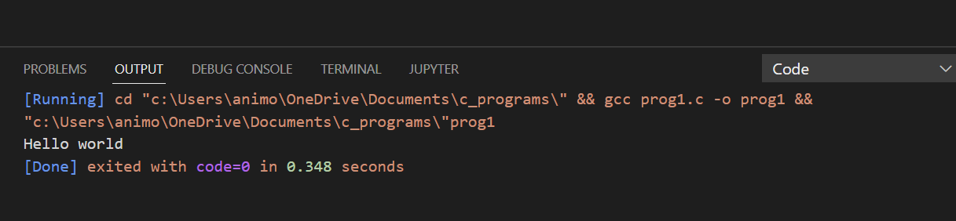

**Exp 2. WAP Name, address, qualification**

**Coding:**

//Name,Address, Qualification//

#include<stdio.h>

int main(){

    printf("Name - Ankesh Mobar\n");

    printf("Address : Sainik Colony Dehradun\n ");

    printf("Qualification:BSC Passout ");

    return 0;

}

**Output** :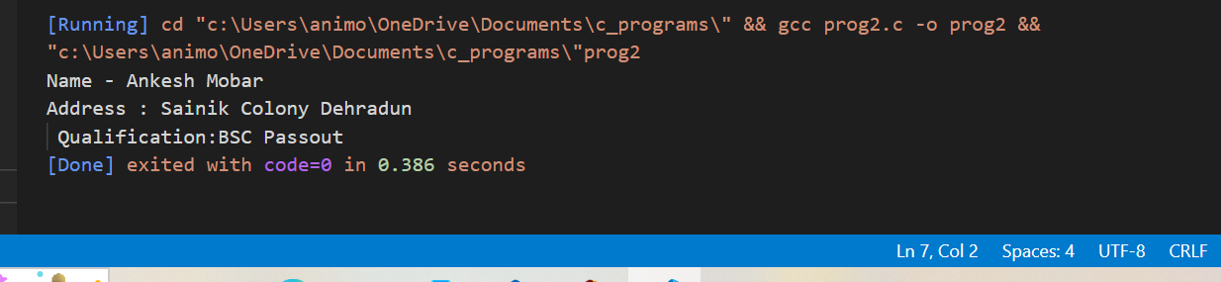

**Exp 3. WAP Add two numbers**

**Coding:**

//Add two number//

#include<stdio.h>

int main(){

    int num1;

    int num2;

    int num3;

    num1=10;

    num2=20;

    num3=num1+num2;

    printf("num3=%d",num3);

    return 0;

}

**Output:**

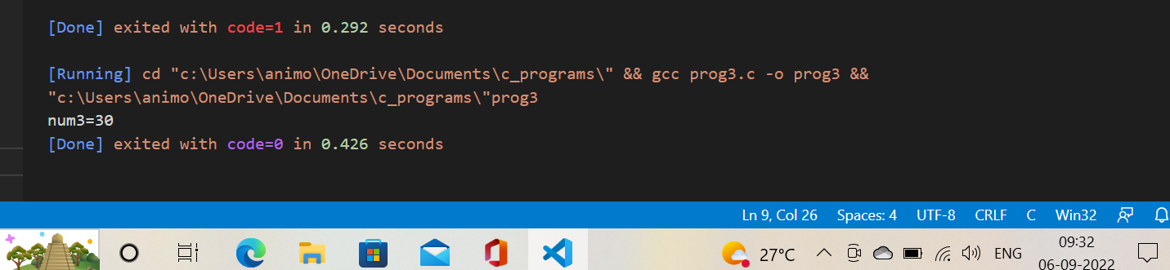

**Exp 4. WAP take input from user & add two numbers.**

**Coding :**

//Take input from user & add two nos.//

#include<stdio.h>

int main(){

    int a,b,sum;

    printf("Enter First number\n");

    scanf("%d",&a);

    printf("Enter second number\n");

    scanf("%d",&b);

    sum=a+b;

    printf("%d",sum);

    return 0;

}

**Output:**

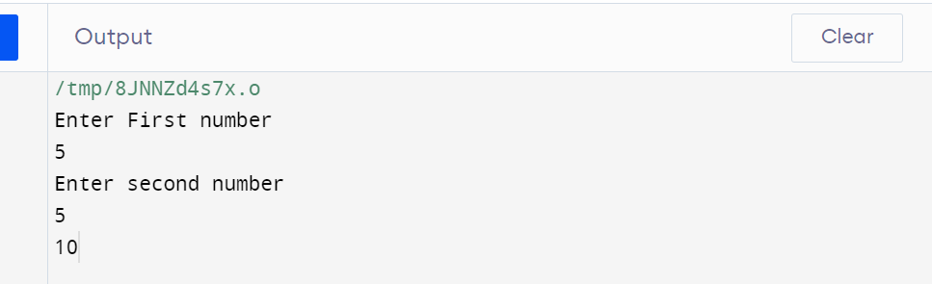

**Exp 5. Distance between two cities in km. Print the distance in meter, feet, inches & centimeter.**

**Coding:**

// Distance between two cities in KM//

#include <stdio.h>

int main() {

float kilometer, centimeter , inches, meter, feet;

printf("Enter the distance between two cities in km=");

scanf("%f",&kilometer);

meter=1000*kilometer;

feet=3280.84*kilometer;

inches=39370.1*kilometer;

centimeter=10000*kilometer;

printf("distance between two cities in meter=%fm\n",meter);

printf("distance between two cities in feet=%ff\n",feet);

printf("distance between two cities in meter=%fin\n",inches);

printf("distance between two cities in meter=%fcm\n",centimeter);

return 0;

}

**Output:**

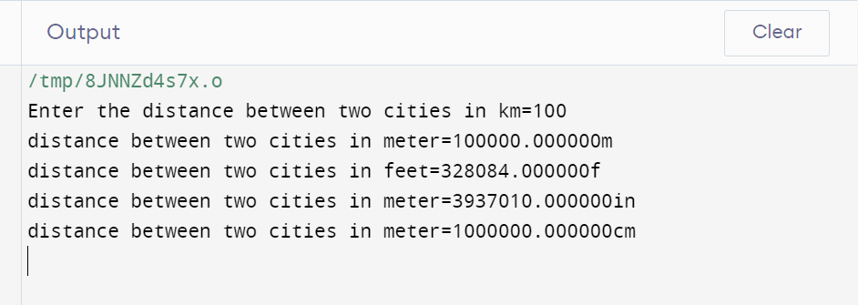

**Exp 6. Take input from user for radius and side of square WAP to print perimeter and circumference.**

**Coding:**

// Perimeter and circumference//

#include <stdio.h>

int main() {

    float circle_circumference, square_perimeter, cir_rad, sq_side;

    printf("please enter the side of square in cm= ");

    scanf("%f", &sq_side);

    printf("please enter the radius of circle in cm= ");

    scanf("%f",&cir_rad);

    circle_circumference=2*3.14*cir_rad;

    square_perimeter=4* sq_side;

    printf("circumference of circle is =%.2f cm\n",circle_circumference);

    printf("perimeter of square is =%.2f cm", square_perimeter);

    return 0;

}

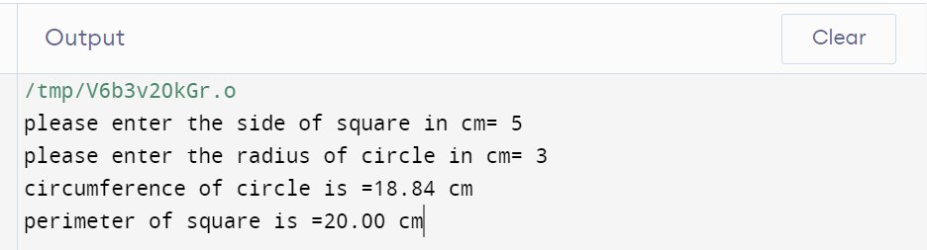

**Exp 7. Paper of size A0 has dimension 1184mm*841mm. Each subsequent size A(n) is defined as A(n-1) cut in parallel to its shorter side. Thus paper of size A1 would have dimension 841mm*594mm WAP to calculate & print paper sizes A0,A1,A3…………..A8.**

**Coding:**

// Find the size of paper//

#include <stdio.h>

int main() {

    int i, height= 1189, width= 841;

    printf("Size of A0 paper %dmm * %dmm\n",height,width);

    printf("Size of A1 paper %dmm * %dmm\n",width, height/2);

    printf("Size of A2 paper %dmm * %dmm\n",height/2,width/2);

    printf("Size of A3 paper %dmm * %dmm\n",width/2,height/4);

    printf("Size of A4 paper %dmm * %dmm\n",height/6,width/4);

    printf("Size of A5 paper %dmm * %dmm\n",width/4, height/8);

    printf("Size of A6 paper %dmm * %dmm\n",height/8,width/8);

    printf("Size of A7 paper %dmm * %dmm\n",width/8, height/16);

    printf("Size of A8 paper %dmm * %dmm\n",height/16,width/16);

    return 0;

}

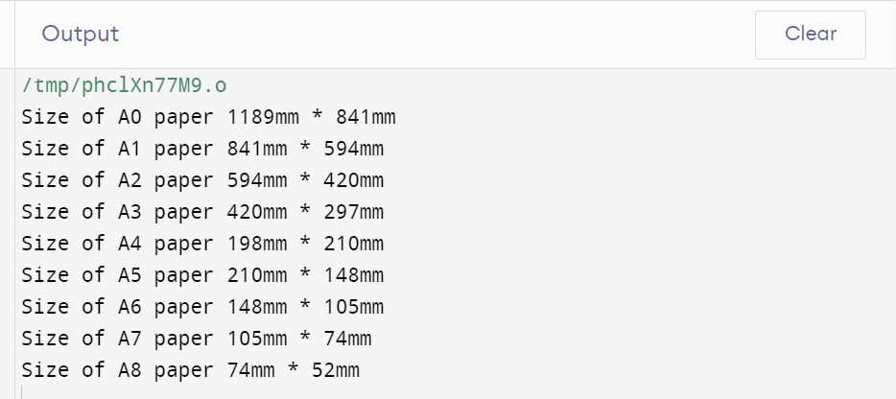

**Exp8. Print the address of a variable.**

**Coding:**

// Find the address of a variable//

#include <stdio.h>

int main() {

    char a;

    printf("Address of variable = %p", &a);

    return 0;

}

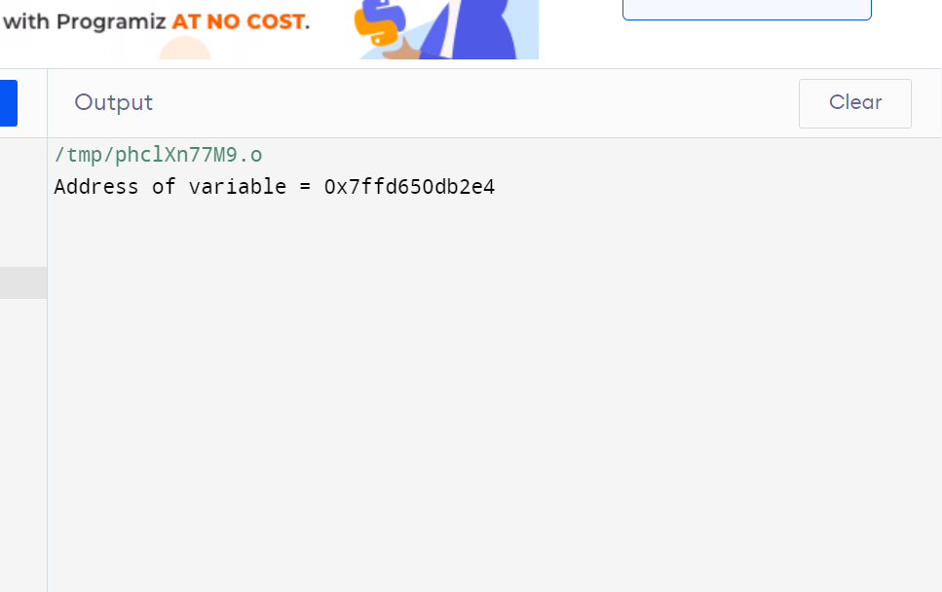

**Exp9. Take a character input from user & print its ASCII Value.**

**Coding:**

// Show the ASCII value of character//

#include <stdio.h>

int main() {

    char c;

    printf("Please enter the character = ");

    scanf("%c",&c);

    printf("ASCII value of %c = %d",c,c);

    return 0;

}

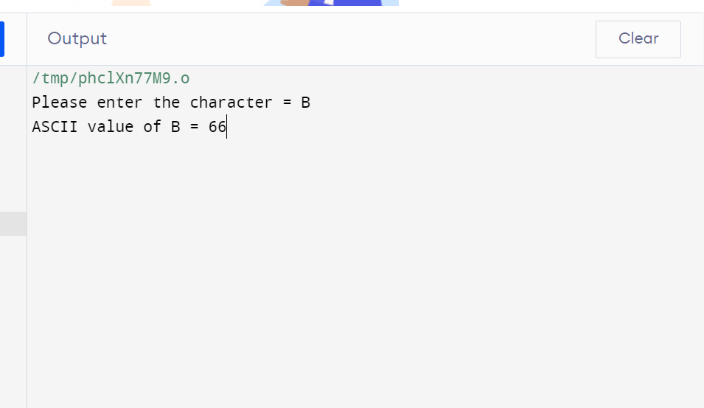

**Exp10. WAP to reverse the number, take input from user.**

**Coding:**

// Take input from user WAP to reverse the number.

#include <stdio.h>

int main() {

    int num,rev=0;

    printf("\nEnter the number to get reverse of it:");

    scanf("%d",&num);

    while(num>0){

        rev=(rev*10)+(num%10);

        num=num/10;

    }

printf("\nThe reverse of the entered is : %d\n\n",rev);

    return 0;

}

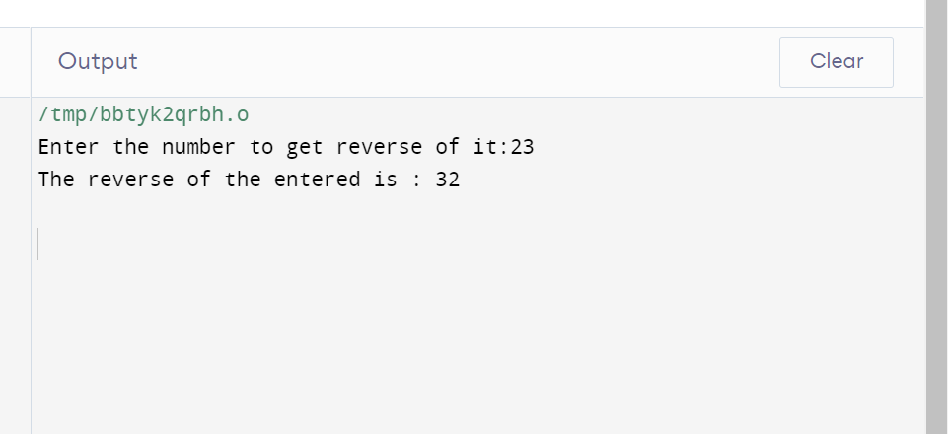

**Exp11. WAP to add the digits of a five digit number.**

**Coding:**

// WAP to Add the digits of a five-digit number.

#include <stdio.h>

int main() {

    int num, sum=0;

    printf("\nEnter any number to get the sum of the digit: ");

    scanf("%d",&num);

    while(num>0){

        sum+=num%10;

        num/=10;

    }

    printf("\nThe sum of all the digits that you have entered is:%d\n\n",sum);

    return 0;

}

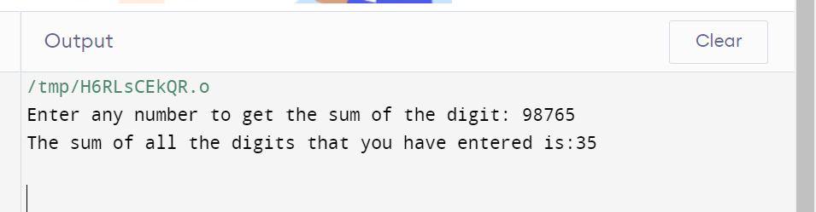

**Exp12. Consider a currency system in which there are notes of seven denominations, namely Rs1, Rs2, Rs5, Rs10, Rs20, Rs50, Rs100. If a sum of Rs N is entered through keyboard, write a program to compute the smallest number of notes that will combine to give Rs N. (While Demonstrating output, give two set of inputs).**

**Coding:**

// Currency system//

#include <stdio.h>

int main() {

    int amount;

    int rs100=0, rs50=0, rs20=0, rs10=0, rs5=0, rs2=0, rs1=0;

    printf("\nEnter the amount to get the denominations: ");

    scanf("%d",&amount);

    rs100=amount/100;

    amount%=100;

    rs50=amount/50;

    amount%=50;

    rs20=amount/20;

    amount%=20;

    rs10=amount/10;

    amount%=10;

    rs5=amount/5;

    amount%=5;

    rs2=amount/2;

    amount%=2;

    rs1=amount/1;

    amount%=1;

    printf("\nNumber of notes of Rs 100\t:%d\nNumber of notes of Rs 50\t:%d\nNumber of notes of Rs 20\t:%d\nNumber of notes of Rs10\t:%d\nNumber of coins of Rs 5\t:%d\nNumber of coins of Rs2\t:%d\nNumber of coins of Rs1\t:%d\n\n",rs100,rs50,rs20,rs10,rs5,rs2,rs1);

    return 0;

}

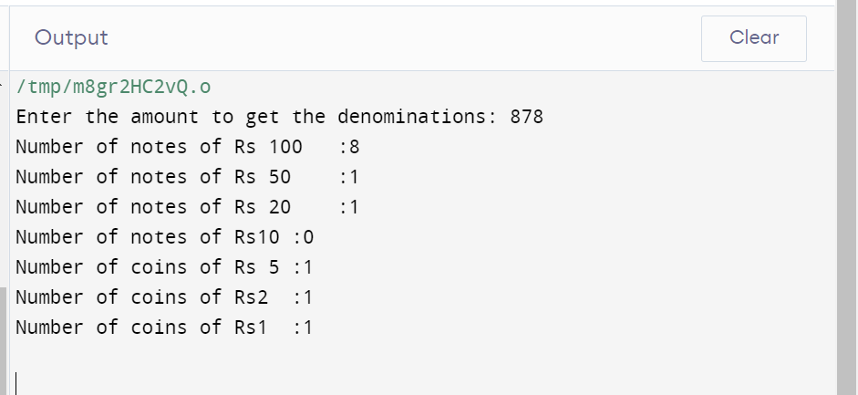

## Assignment: 2

**Experiment no 1: WAP to take check if the triangle is valid or not. If the validity is established, do check if the triangle is isosceles, equilateral, right angle, or scalene. Take sides of the triangle as input from a user.**

**Coding:**

#include<stdio.h>

int main()

{

   int a, b, c;

   printf("Enter sides of triangle:");

   scanf("%d%d%d",&a,&b,&c);

   if ((a+b>c) && (b+c>a) && (c+a>b)){

      printf("It is a Valid Triangle\n");

   if(a == b && b == c)

      printf("The Given Triangle is equilateral\n");

   else if(a == b || b == c || c == a)

      printf("The given Triangle is isosceles\n");

   else

      printf("The given Triangle is scalene\n");

  }

  else{printf(" It is an invalid Triangle");

  }

   return 0;

}

**Output:**

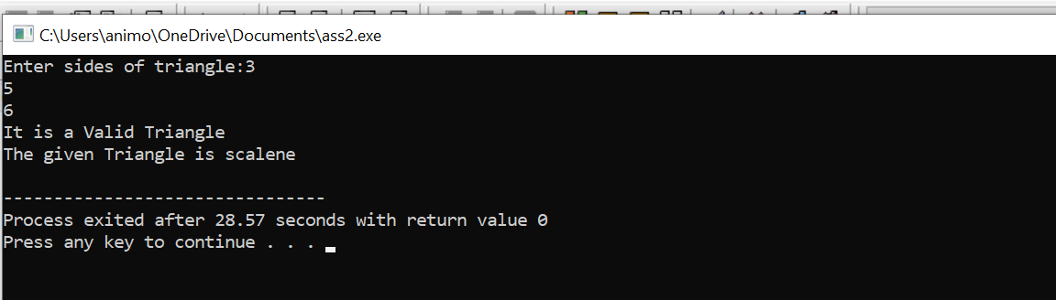

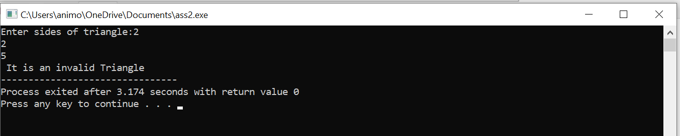

**Experiment no 2: WAP to compute the BMI Index of the person and print the BMI values as per the following ranges. You can use the following formula to compute BMI= weight(kgs)/Height(Mts)*Height(Mts)**

**Coding:**

#include<stdio.h>

void main(){

   float bmi,weight,height;

   printf("enter weight in kg and height in m");

   scanf("%f %f",&weight,&height);

   bmi=weight/(height *height);

   if(bmi<15){

      printf("starvation");

   }

   else if(bmi>=15.1&&bmi<=17.5){

      printf("anorexic");

}

   else if(bmi>=17.6&&bmi<=18.5){

   printf("underweight");

   }

   else if(bmi>=18.6&&bmi<=24.9){

   printf("ideal");

   }

   else if(bmi>=25&&bmi<=25.9){

   printf("overweight");

   }

   else if(bmi>=30&&bmi<=39.9){

   printf("obese");

   }

else if(bmi>40){

   printf("mostly obese");

}  else

{

   printf("error");

}

}

**Output:**

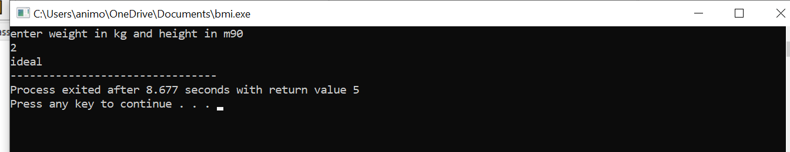

**Experiment no 3: WAP to check if three points (x1,y1), (x2,y2) and (x3,y3) are collinear or not.**

**Coding:**

#include<stdio.h>

void main(){

   int y2,y1,x2,x1,y3,x3;

   printf("enter the coodinates");

   scanf("%d %d %d %d %d %d",&x1,&y1,&x2,&y2,&x3,&y3);

   int m=(y2-y1)/(x2-x1);

   int m2=(y3-y2)/(x3-x2);

   if(m==m2){

      printf("colinear");

   }

   else

   {

      printf("non colinear");

   }

}

**Output:**

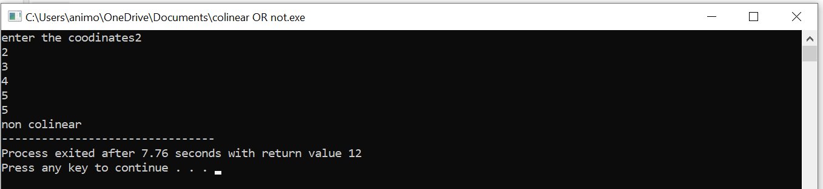

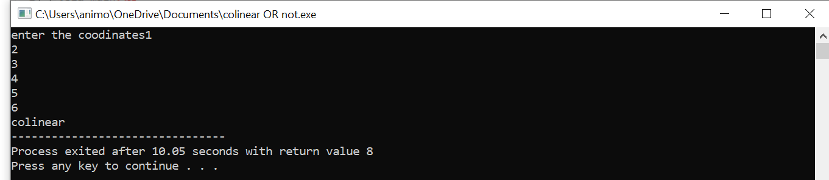

**Experiment No 4: According to the gregorian calendar, it was Monday on the date 01/01/01. If Any year is input through the keyboard write a program to find out what is the day on 1st January of this year.**

**Coding:**

#include<stdio.h>

int main()

{

   int year, basicyear=2000, leapyear, remainingyear, totaldays, day;

   printf("Please enter the year:  ");

   scanf("%d",&year);

   year= (year-1)-basicyear;

   leapyear=year/4;

   remainingyear= year-leapyear;

   totaldays=(remainingyear*365)+(leapyear*366)+1;

   day=totaldays%7;

   if(day==0)

   printf("Monday");

   else if(day==1)

   printf("Tuesday");

   else if (day==2)

   printf("Wednesday");

   else if (day==3)

   printf("Thusday");

   else if(day==4)

   printf("Friday");

   else if(day==5)

   printf("Saturday");

   else if (day==6)

   printf("Sunday");

   else

   printf("Wrong entry");

   return 0;

}

**Output:**

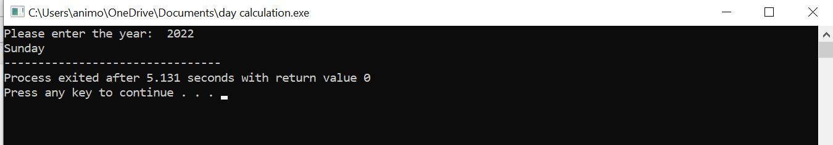

**Experiment 5: WAP using ternary operator, the user should input the length and breadth of a rectangle, one has to find out which rectangle has the highest perimeter. The minimum number of rectangles should be three.**

**Coding:**

#include<stdio.h>

int main(){

   int l1,l2,l3,w1,w2,w3,peri1,peri2,peri3;

   printf("please enter the three conjugative length and width of rectangles\n");

   scanf("%d%d%d%d%d%d", &l1, &l2, &l3, &w1, &w2, &w3);

   peri1=2*(l1+w1);

   peri2=2*(l2+w2);

   peri3=2*(l3+w3);

   peri1>peri2?peri1>peri3?printf("First retangle has largest perimeter"):printf("Third retangle has largest perimeter"):peri2>peri3?printf("Second rectangle has largest perimeter"):printf("Third rectangle has largest perimeter");

   return 0;

}

**Output:**

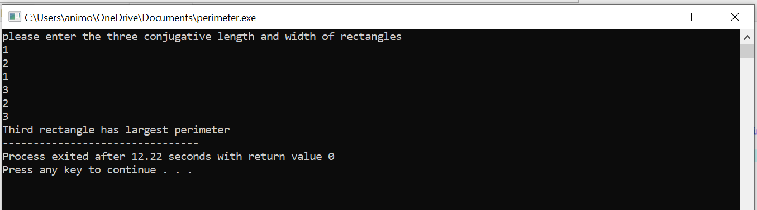

## Assignment: 3

Experiment 1: WAP to enter numbers till the user wants. At the end, it should display the count of positive, negative, and Zeroes entered.

**Coding:**

#include<stdio.h>

main()

{

//count=c

   int i, num, c_p=0, c_n=0, c_z=0;

   int arr[100];

   printf("Enter Number: ");

   scanf("%d", &num);

   for (i=0;i<num;++i)

   {

      scanf("%d", &arr[i]);

   }

   for(i=0;i<num;++i)

   {

      if(arr[i]>0)

      {

      ++c_p;

      }

      else if(arr[i]<0)

      {

         ++c_n;

      }

      else if(arr[i]==0)

      {

         ++c_z;

      }

      else

      {

         printf("Wrong Entry\n");

         break;

      }

   }

   printf("+ve Number: %d\n", c_p);

   printf("-ve Number: %d\n", c_n);

   printf(" Zero Number: %d\n", c_z);

}

**Output:**

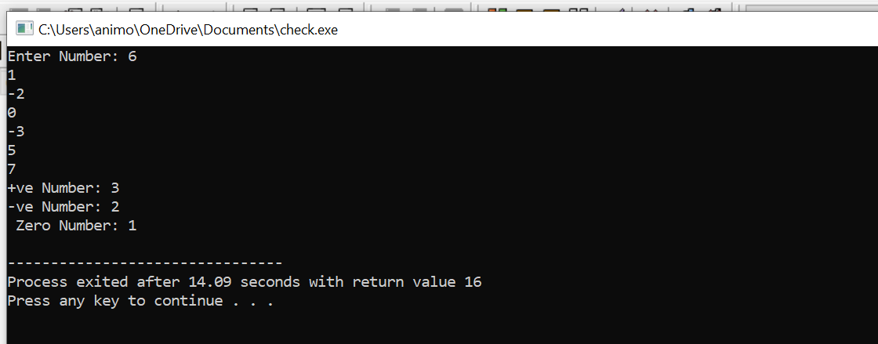

Experiment 2: WAP to print the multiplication table of the number entered by the user. It should be in the correct formatting.

Num * 1 = Num

**Coding:**

#include<stdio.h>

main()

{

    int i,num;

   printf("Enter Any Number: ");

   scanf("%d",&num);

   printf("\nTable For The Given Number: ");

   for(i=1;i<=10;i++)

   {

    printf("\n%d * %d = %d",num,i,num*i);

   }

   return 0;

}

**Output:**

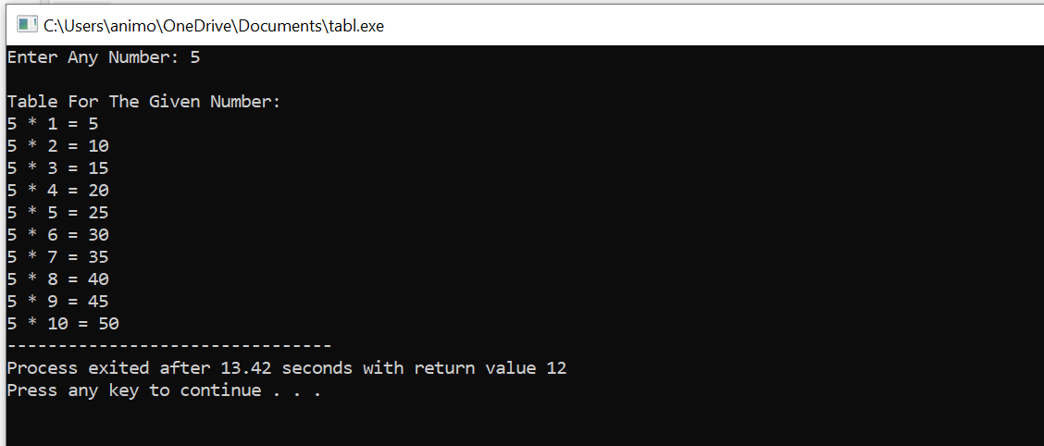

**Experiment 3: WAP to generate the following set of output.**

1. **1**

**2 3**

**4 5 6**

**Coding:**

#include<stdio.h>

int main()

{

   int i,j,k=1;

   for(i=1;i<=3;i++)

   {

      for(j=3;j>=1;j--)

      {

         if(j>i)

         printf("");

         else

         printf("%d", k++);

      }

      printf("\n");

   }

   return 0;

}

**Output:**

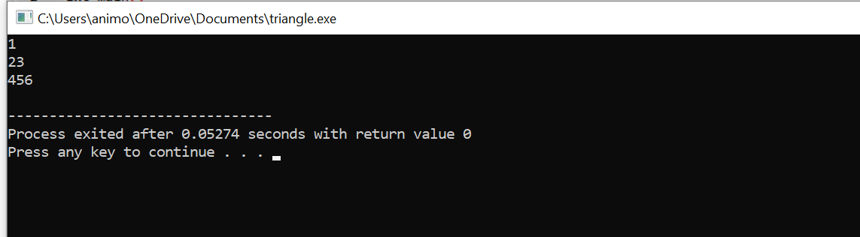

1. **1**

**1 1**

**1 2 1**

**1 3 3 1**

**1 4 6 4 1**

**Coding:**

#include<stdio.h>

int main()

{

   //row=r, coloumn=c

   int val=1,r,c;

   {

      for(r=0;r<5;r++)

      {

      for(c=0;c<=r;c++)

      {

         if(r==0 || c==0)

         val=1;

         else

         val=val*(r-c+1)/c;

         printf("%5d", val);

      }

      printf("\n");

   }

}

    return 0;

}

**Output:**

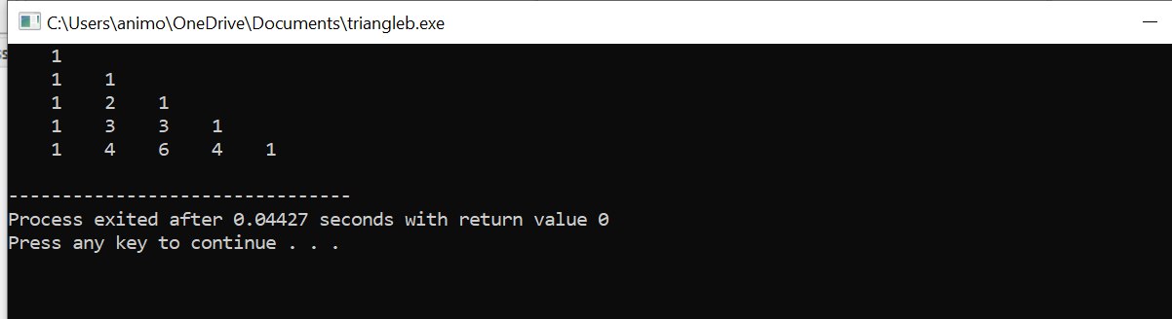

**Experiment 4: The population of a town is 100000. The population has increased steadily at the rate of 10% per year for the last 10 years. Write a program to determine the population at the end of each year in the last decade.**

**Coding:**

#include<stdio.h>

int main()

{

   int i , population=100000;

   for(i=1;i<=10;i++)

   {

      population = population - population*0.1;

      printf("%d year: %d\n", i,population);

   }

   return 0;

}

**Output**

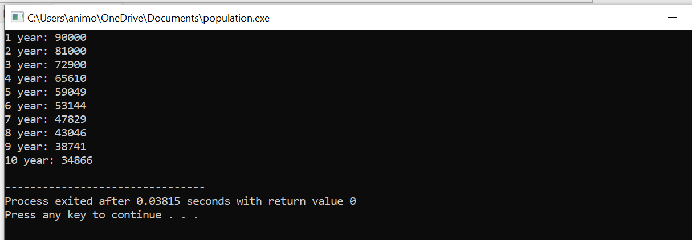

## Assignment: 4

**Exp 1: WAP for printing Fibonacci sequence. Take input from the user to print up to a certain limit.**

Coding:

#include <stdio.h>

void fi(int);

int main()

{

    //nt= nextterm

  int n;

  printf("Enter a +ve number: ");

  scanf("%d", &n);

  fi(n);

  return 0;

}

void fi(int size)

{

    int t1 = 0, t2 = 1, nt = 0;

    printf("Fibonacci Series: %d, %d, ", t1, t2);

    nt = t1 + t2;

    while (nt <= size)

  {

    printf("%d, ", nt);

    t1 = t2;

    t2 = nt;

    nt = t1 + t2;

  }

}

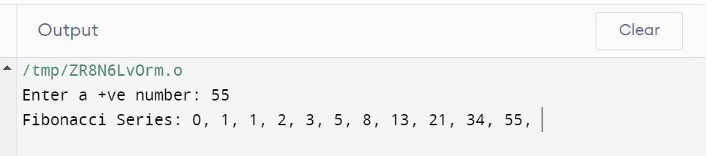

**Exp 2: WAP to swap two variables without using a third variable, depict the same using call by value concept.**

Coding:

#include <stdio.h>

void swap(int , int);

int main()

{

    int a;

    int b;

    printf("Enter a valid number");

    scanf("%d%d", &a,&b);

    swap(a,b);

}

void swap (int a, int b)

{

    int temp;

    temp = a;

    a=b;

    b=temp;

    printf("After swapping values in function a = %d, b = %d\n",a,b);

}

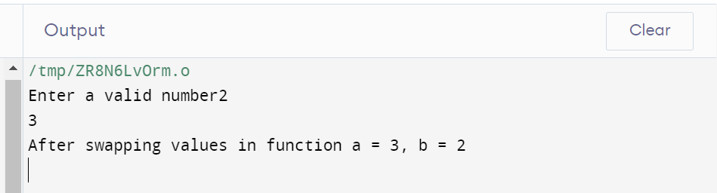

**Exp 3: A positive integer is entered through the keyboard. Write a Function to print the prime factors of this number.**

Coding:

#include<stdio.h>

int isprime(int val){

int flag=1;

if(val!=2&&val%2==0)

return flag=0;

if(val==2||val==3)

return flag=1;

for(int i=2;i<val/2;i++){

if(val%i==0)

flag=0;

}

return flag;

}

void primefactor(int num){

int n=num,i=2;

while(num!=1){

if(num%i==0){

if(isprime(i)){

printf("%d, ",i);

num=num/i;

}

}

else{

i++;

}

}

}

int main(){

int num;

printf("Enter a value: ");

scanf("%d",&num);

primefactor(num);

}

Output: 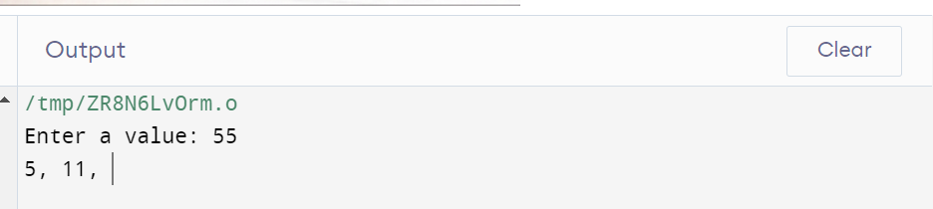

## Assignment: 5

## Exp A. WAP to implement the following scenarios. Take all the input from user, nothing should be imagined or hard coded.

1. Transpose of a matrix.
2. Check if a matrix is Symmetrical or not.

## Coding:

#include <stdio.h>

int main() {

  int a[100][100], transpose[100][100], r, c;

  printf("Enter rows and columns: ");

  scanf("%d %d", &r, &c);

  printf("\nEnter matrix elements:\n");

  for (int i = 0; i < r; ++i)

  for (int j = 0; j < c; ++j) {

    printf("Enter element a%d%d: ", i + 1, j + 1);

    scanf("%d", &a[i][j]);

  }

  printf("\nEntered matrix: \n");

  for (int i = 0; i < r; ++i)

  for (int j = 0; j < c; ++j) {

    printf("%d  ", a[i][j]);

    if (j == c - 1)

    printf("\n");

  }

  for (int i = 0; i < r; ++i)

  for (int j = 0; j < c; ++j) {

    transpose[j][i] = a[i][j];

  }

  printf("\nTranspose of the matrix:\n");

  for (int i = 0; i < c; ++i)

  for (int j = 0; j < r; ++j) {

    printf("%d  ", transpose[i][j]);

    if (j == r - 1)

    printf("\n");

  }

  int Count=1;

  for(int rows = 0; rows < r; rows++)

    {

        for(int columns = 0; columns < c; columns++)

        {

            if(a[rows][columns] != transpose[rows][columns])

            {

                Count++;

                break;

            }

        }

    }

    if(Count == 1)

    {

        printf("\n The Matrix that you entered is a Symmetric Matrix ");

    }

    else

    {

        printf("\n The Matrix that you entered is Not a Symmetric Matrix ");

    }

  return 0;

}

## Output:

## 

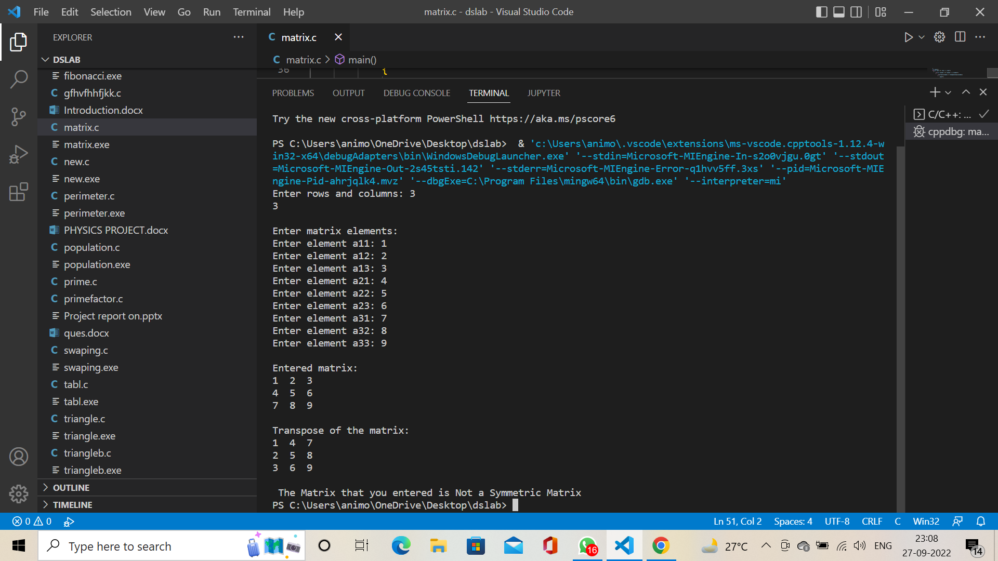

**Exp B. WAP to merge two arrays and append them in the following order.**

1. Add the first array to the end of another one
2. Add Second Array to the end of the first one
3. Merge the arrays and sort them.

**Coding:**

#include <stdio.h>

int mergearray(int a[], int b[], int arr1size, int arr2size)

{

    int arr_resultsize = arr1size + arr2size;

    int c[arr_resultsize], i, j;

    for (i = 0; i < arr1size; i++) {

        c[i] = a[i];

    }

    for (i = 0, j = arr1size;

         j < arr_resultsize && i < arr2size; i++, j++) {

        c[j] = b[i];

    }

   int aa, n=arr_resultsize;

   for (i = 0; i < n; ++i){

      for (j = i + 1; j < n; ++j){

         if (c[i] > c[j]){

            aa = c[i];

            c[i] = c[j];

            c[j] = aa;

         }

      }

   }

   printf("The merged sorted array is:\n");

    for (i = 0; i < arr_resultsize; i++) {

        printf("%d ", c[i]);

    }

}

int main()

{

    int arr1size = 5, arr2size = 5;

    int a[5] = { 1, 2, 4, 4, 8 };

    int b[5] = { 6, 8, 8, 11, 4 };

    printf("%d", mergearray(a, b, arr1size, arr2size));

    return 0;

}

**Output:**

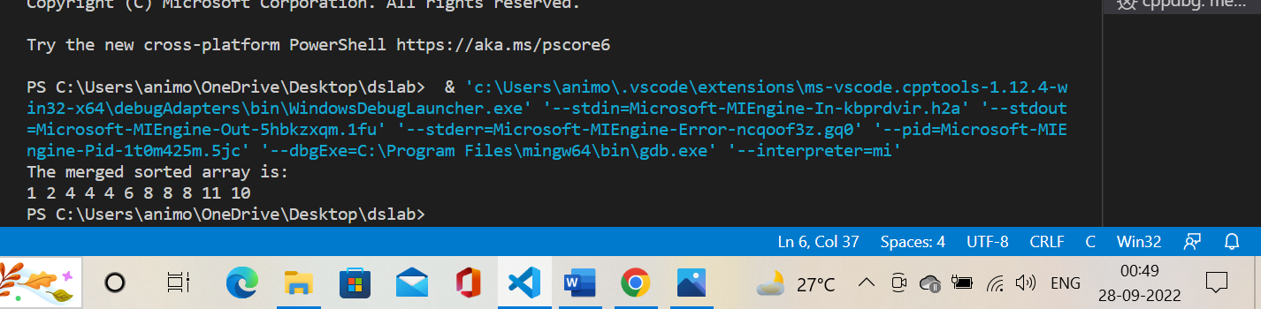

**Exp C.** WAP using pointers to find the smallest number in an array using pointer.

**Coding:**

# include <stdio.h>

int  main()

{

int  arr[50],n,i,small ;

int  *ptr ;

printf("Enter the length of numbers: ");

scanf("%d", &n) ;

printf("Please enter %d number : \n",n);

for (i = 0; i < n-1 ; i++)

{

scanf("%d ",& arr[i]);

ptr++ ;

}

ptr = & arr[0];

small = arr[0];

{

if ( small > ( *ptr ))

small = *ptr ;

ptr++ ;

}

printf("\n Smallaest element is : %d",small) ;

return 0;

}

**Output:**

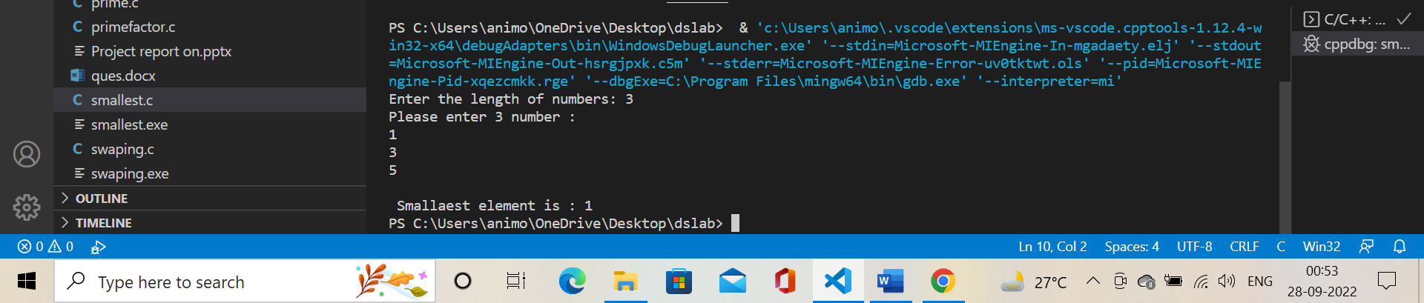

**Exp D.** WAP which performs following task.

1. Initialize an integer array of 10 elements in main()
2. Pass the entire array to a function modify()
3. In modify() multiply(you can use division, addition or subtraction) each element of array by 3
4. Return the control to main() and print the new array elements in main().

**Coding:**

#include<stdio.h>

void modify(int data[]){

    for(int i = 0; i < 10; i++) data[i] *= 3;

}

void main()

{

    int i;

    int data[] = {1,2,3,4,5,6,7,8,9,10};

    modify(data);

    printf("Multiplied array : ");

    for(i=0;i<10;i++){

        printf("%d ",data[i]);

    }

}

**Output:**

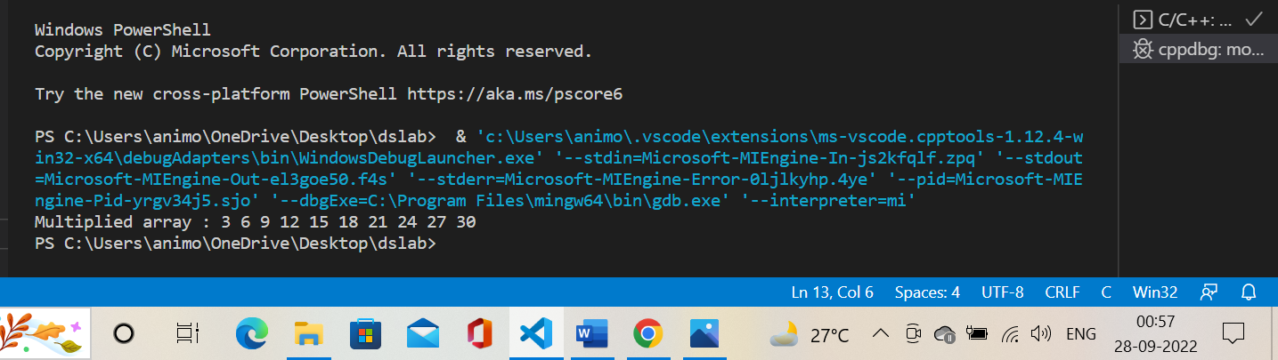

**Assignment: 6**

**Exp 1.** A record contains the name of a cricketer, his age, the number of tests matches he has played, and the **average** runs he scored in each test match. Create an array of structures to hold records of 20 such cricketers and then write a program to read these records and arrange them in ascending order by runs, Use the qsort standard library function.

**Coding:**

#include<stdio.h>

struct cricketer{

   char name[50];

   int age;

   int match;

   float avrn;

};

int main() {

   int i,j,n;

   printf("enter number of crickters:");

   scanf("%d",&n);

 struct cricketer c[n],temp1;

   for(i=0;i<n;i++){

       printf("Enter data of cricketer \n");

      printf("Name: ");

      scanf("%s",c[i].name);

      printf("Age: ");

      scanf("%d",&c[i].age);

      printf("Matches: ");

      scanf("%d",&c[i].match);

      printf("Average runs: ");

      scanf("%f",&c[i].avrn);

   }for(i=0;i<n;i++) {

      for(j=i+1;j<n;j++) {

         if(c[i].avrn > c[j].avrn){

            temp1=c[i];

            c[i]=c[j];

            c[j]=temp1;

         }

      }

   }

   printf("Sorted records:\n");

   for(i=0;i<n;i++){

      printf("%d\t%s\t%d\t%d\t%f\n\n\n",i+1,c[i].name,c[i].age,c[i].match,c[i].avrn);

   }

   return 0;

}

**Output:**

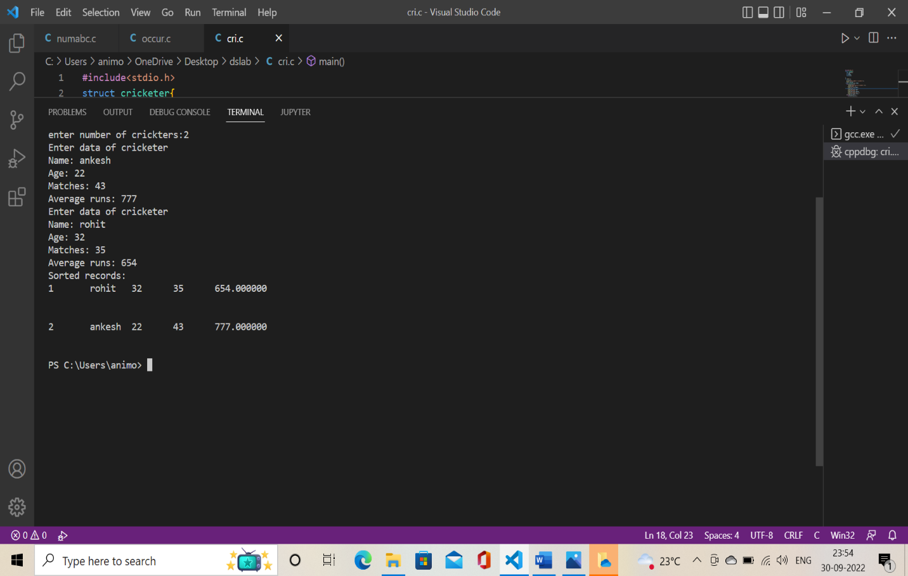

**Exp 2.** Create a structure to specify data of customers in a bank. The data to be stored is Account number, Name, and Balance in the account. Assume a maximum of 200 customers in the bank.

1. Write a function to print the account number and name of each customer with a balance below Rs 100.
2. If a customer requests for withdrawal or deposit, the form contains the fields: Acct no, amount, code (1 for deposit and 0 for withdrawal) WAP to give a message " The balance is insufficient for the specified withdrawal", if on withdrawal the balance falls below Rs 100.

**Coding:**

**Output:**

**Exp 3.** WAP to count the number of occurrences of any two vowels in succession in a line of text. For example, in the following sentence "Please read this application and give me gratuity". such occurrences, ea, ea and ui.

**Coding:**

#include<stdio.h>

#include<strings.h>

#include<string.h>

int main()

{

    int a=0,i,len;

    char str[100];

    printf("Enter a String: ");

    scanf("%[^\n]%*c",str);

    printf("%s\n",str);

    len=strlen(str);

    for(i=0;i<len;i++)

    {

        if((str[i]=='a'||str[i]=='e'||str[i]=='i'||str[i]=='o'||str[i]=='u'||str[i]=='A'||str[i]=='E'||str[i]=='I'||str[i]=='O'||str[i]=='U')&&(str[i+1]=='a'||str[i+1]=='e'||str[i+1]=='i'||str[i+1]=='o'||str[i+1]=='u'||str[i+1]=='A'||str[i+1]=='E'||str[i+1]=='I'||str[i+1]=='O'||str[i+1]=='U'))

        {

            printf("%c",str[i]);

            printf("%c ",str[i+1]);

            printf(" ");

        }

    }

    return 0;

}

**Output:**

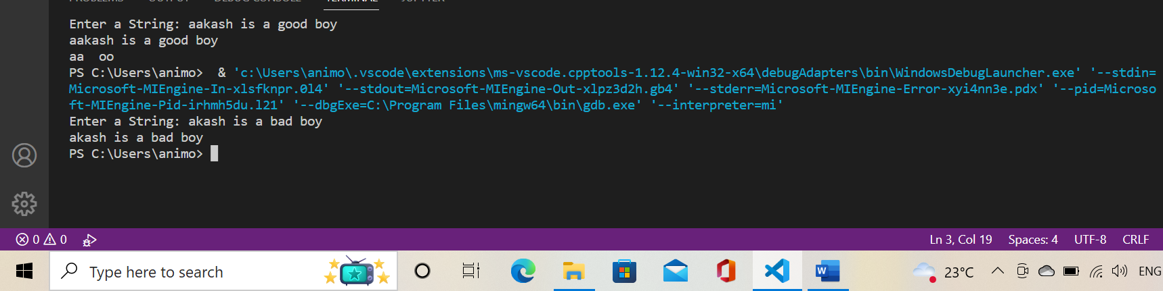

**Exp 4.** WAP to receive an integer and printout the number in words. For example, if the number is 5678, it should print Five thousand six hundred and seventy-eight.

**Coding:**

#include<stdio.h>

#include<string.h>

void numberInUnits(int num)

{

    switch(num)

    {

        case 1:

            printf("One ");

            break;

        case 2:

            printf("Two ");

            break;

        case 3:

            printf("Three ");

            break;

        case 4:

            printf("Four ");

            break;

        case 5:

            printf("Five ");

            break;

        case 6:

            printf("Six ");

            break;

        case 7:

            printf("Seven ");

            break;

        case 8:

            printf("Eight ");

            break;

        case 9:

            printf("Nine ");

            break;

    }

}

void numberInTens(int num)

{

    int tensDigit = num/10;

    int unitsDigit = num%10;

    if(tensDigit == 1)

    {

        switch(unitsDigit)

        {

            case 0:

                printf("Ten ");

                break;

            case 1:

                printf("Eleven ");

                break;

            case 2:

                printf("Twelve ");

                break;

            case 3:

                printf("Thirteen ");

                break;

            case 4:

                printf("Fourteen ");

                break;

            case 5:

                printf("Fifteen ");

                break;

            case 6:

                printf("Sixteen ");

                break;

            case 7:

                printf("Seventeen ");

                break;

            case 8:

                printf("Eighteen ");

                break;

            case 9:

                printf("Ninteen ");

                break;

        }

    }

    else

    {

        switch(tensDigit)

        {

            case 2:

                printf("Twenty ");

                break;

            case 3:

                printf("Thirty ");

                break;

            case 4:

                printf("Forty ");

                break;

            case 5:

                printf("Fifty ");

                break;

            case 6:

                printf("Sixty ");

                break;

            case 7:

                printf("Seventy ");

                break;

            case 8:

                printf("Eighty ");

                break;

            case 9:

                printf("Ninety ");

                break;

        }

        numberInUnits(unitsDigit);

    }

}

void numberInHundreds(int num)

{

    if(num/100)

    {

        numberInUnits(num/100);

        if(num%100) printf("hundred and ");

        else printf("hundred ");

        numberInTens(num%100);

    }

    else numberInTens(num%100);

}

void numberInThousands(int num)

{

    if(num/1000)

    {

        numberInUnits(num/1000);

        printf("thousand ");

        numberInHundreds(num%1000);

    }

    else numberInTens(num%1000);

}

void numberInTenThousands(int num)

{

    if(num/1000)

    {

        numberInTens(num/1000);

        printf("thousand ");

        numberInHundreds(num%1000);

    }

    else numberInHundreds(num%1000);

}

void numberInHundredThousands(int num)

{

    if(num/100000)

    {

        numberInHundreds(num/1000);

        printf("thousand ");

        numberInHundreds(num%1000);

    }

    else numberInTenThousands(num%10000);

}

void numberInMillions(int num)

{

    if(num/1000000)

    {

        numberInUnits(num/1000000);

        printf("million ");

        numberInHundredThousands(num%1000000);

    }

    else numberInHundredThousands(num%1000000);

}

void numberInTenMillions(int num)

{

    if(num/10000000)

    {

        numberInTens(num/1000000);

        printf("million ");

        numberInHundredThousands(num%1000000);

    }

    else numberInMillions(num%10000000);

}

void numberInHundredMillions(int num)

{

    if(num/100000000)

    {

        numberInHundreds(num/1000000);

        printf("million ");

        numberInHundredThousands(num%1000000);

    }

    else numberInTenMillions(num%100000000);

}

void numberInBillions(int num)

{

    if(num/1000000000)

    {

        numberInUnits(num/1000000000);

        printf("billion ");

        numberInHundredMillions(num%1000000000);

    }

    else numberInHundredMillions(num%1000000000);

}

void main()

{

    int i, j, n, temp, num[10];

    printf("Enter any number: ");

    scanf("%d", &n);

    temp = n;

    while(temp)

    {

        temp /= 10;

        i++;

    }

    switch(i)

        {

            case 1:

                numberInUnits(n);

                break;

            case 2:

                numberInTens(n);

                break;

            case 3:

                numberInHundreds(n);

                break;

            case 4:

                numberInThousands(n);

                break;

            case 5:

                numberInTenThousands(n);

                break;

            case 6:

                numberInHundredThousands(n);

                break;

            case 7:

                numberInMillions(n);

                break;

            case 8:

                numberInTenMillions(n);

                break;

            case 9:

                numberInHundredMillions(n);

                break;

            case 10:

                numberInBillions(n);

                break;

        }

}

**Output:**

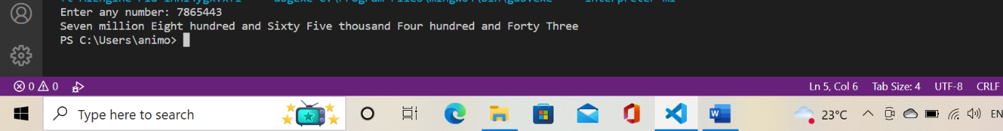

**Assignment: 7**

**Exp.1.** WAP to demonstrate the union's effectiveness over structure. You can use any previously given structure program to depict the idea.

**Coding:** #include<stdio.h>

#include<string.h>

#include<stdlib.h>

struct cricket_player {

    char player_name[50];

    int player_age;

    int number_matches;

    int avg_run;

}c[20];

union cricket_player_u {

    char player_name_u[50];

    int player_age_u;

    int number_matches_u;

    int avg_run_u;

}b[20];

// for structure

int main(){

      int i,n;

      printf("Enter the number of player for structure ");

      scanf("%d",&n);

      c;

      for(i=0;i<n;i++){

      printf("Enter data of %d cricketer \n", i+1);

      printf("Player Name: ");

      scanf("\n");

      scanf("%[^\n]%*c",c[i].player_name);

      printf("Player Age: ");

      scanf("%d",&c[i].player_age);

      printf("Matches Played: ");

      scanf("%d",&c[i].number_matches);

      printf("Average runs: ");

      scanf("%d",&c[i].avg_run);

   }

      printf("\nPlayer name \t Avg run");

      for(i=0;i<n;i++){

      printf("\n%s\t\t %d",c[i].player_name,c[i].avg_run);

      printf("\n");

   }

// for union

      int j,k;

      printf("Enter the number of player for union ");

      scanf("%d",&k);

      b;

      for(j=0;j<k;j++){

      printf("Enter data of %d cricketer \n", j+1);

      printf("Player Name: ");

      scanf("\n");

      scanf("%[^\n]%*c",b[j].player_name_u);

      printf("Player Age: ");

      scanf("%d",&b[j].player_age_u);

      printf("Matches Played: ");

      scanf("%d",&b[j].number_matches_u);

      printf("Average runs: ");

      scanf("%d",&b[j].avg_run_u);

   }

      printf("\nPlayer name \t Avg run");

      for(j=0;i<k;j++){

      printf("\n%s\t\t %d",b[j].player_name_u,b[j].avg_run_u);

      printf("\n");

   }

   printf("\n\nSize of structure is %lu bytes",sizeof(struct cricket_player));

   printf("\n\nSize of Union is %lu bytes",sizeof(union cricket_player_u));

   return 0;

}

**Output:**

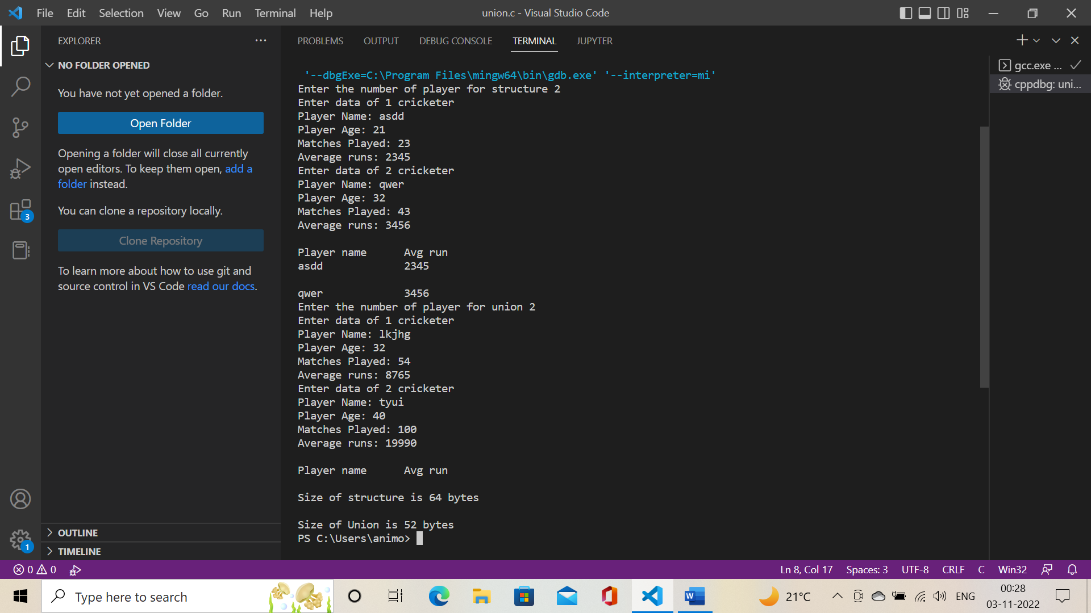

**Exp.2.** WAP to demonstrate the various run-time memory allocation approaches like

 a. Malloc

 b. Calloc

 c. Free

 d. Realloc

For implementing this, make use of array, function, and wherever necessary pointer.

**Coding:** #include<stdio.h>

#include<stdlib.h>

#include<string.h>

#define NUMBER_OF_ELEMENTS 100

int main()

{

    int *parr=calloc(NUMBER_OF_ELEMENTS,sizeof(int));

    if (parr==NULL)

    {

        printf("Couldn't allocate memory through calloc\n");

    }

    else

    {

        printf("Memory allocation successful with calloc\n");

    }

    int *barr=malloc(NUMBER_OF_ELEMENTS*sizeof(int));

    if(barr==NULL)

    {

        printf("Couldn't allocate memory through malloc\n");

    }

    else

    {

        memset(barr,0,NUMBER_OF_ELEMENTS*sizeof(barr[0]));

        printf("Memory allocation successful with malloc\n");

    }

    int *carr=calloc(NUMBER_OF_ELEMENTS,sizeof(int));

    if(carr==NULL)

    {

        printf("Couldn't allocate memory");

    }

    else

    {

        printf("Memory allocation successful\n");

        carr=realloc(carr,(NUMBER_OF_ELEMENTS/2)*sizeof(int));

        if (carr==NULL)

        {

            printf("Memory reallocation fails");

        }

        else

        {

            printf("Memory reallocation successful");

        }

    }

    printf("\nsizeof parr = %d", sizeof(parr));

    free(parr);

    parr=NULL;

    return 0;

**Output:** 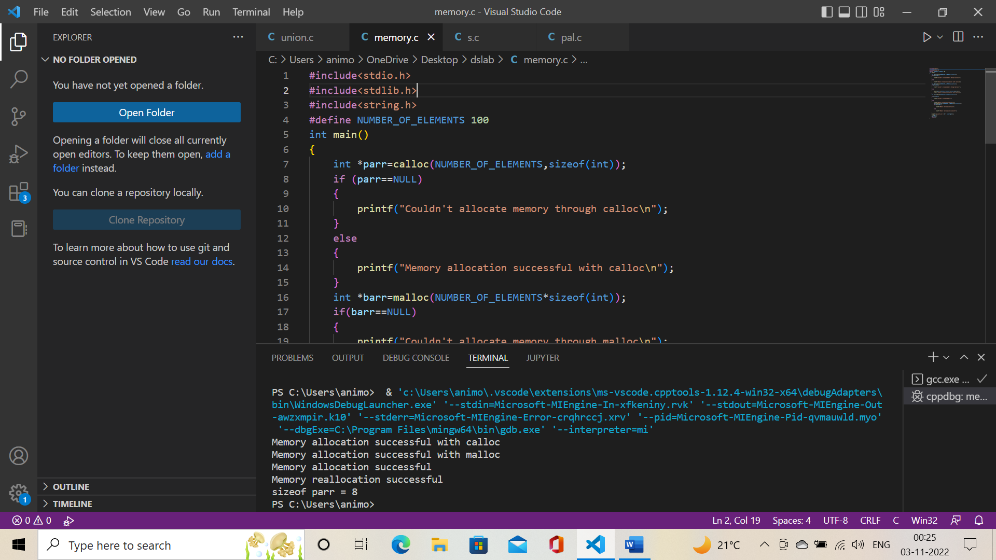

**Assignment: 8**

**Exp.1.** Write code to implement Stack Data structures. Implement the Push and Pop operation in the stack.

**Coding:**

#include<stdio.h>

#include<stdlib.h>

#define size 5

int top=-1,ar[size];

void Push();

void Pop();

void show();

int main()

{

    int choice;

    while(1)

    {

        printf("\nOperations performed by Stack");

        printf("\n1.Push the element\n2.Pop the element\n3.Show\n4.End");

        printf("\n\nEnter your choice: ");

        scanf("%d",&choice);

        switch(choice)

        {

            case 1: Push();

                    break;

            case 2: Pop();

                    break;

            case 3: show();

                    break;

            case 4: exit(0);

            default: printf("\nInvalid choice!!");

        }

    }

    return 0;

}

void Push()

{

    int num;

    if(top==size-1)

    {

        printf("\nStack Overflowed");

    }

    else

    {

        printf("\nEnter Number To Be Added To Stack: ");

        scanf("%d",&num);

        top=top+1;

        ar[top]=num;

    }

}

void Pop()

{

    if(top==-1)

    {

        printf("\nStack Is Now Empty");

    }

    else

    {

        printf("\nElement Popped is %d",ar[top]);

        top=top-1;

    }

}

void show()

{

    int i;

    if(top==-1)

    {

        printf("\nThe Stack Is empty");

    }

    else

    {

        printf("\nElements Of The Stack are: \n");

        for(i=top;i>=0;i--)

        {

            printf("%d",ar[i]);

            printf("\n");

        }

    }

}

**Output:**

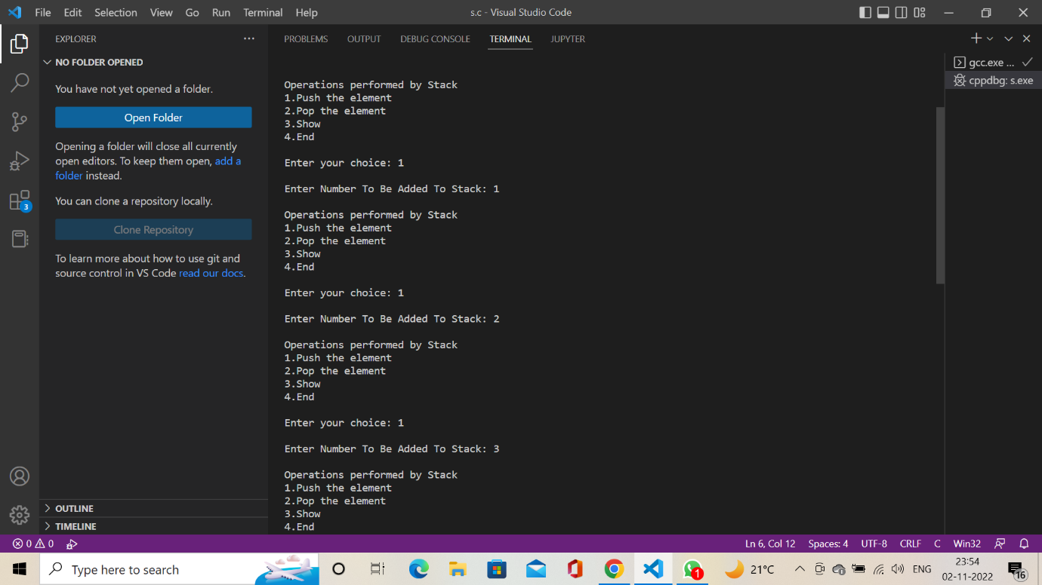

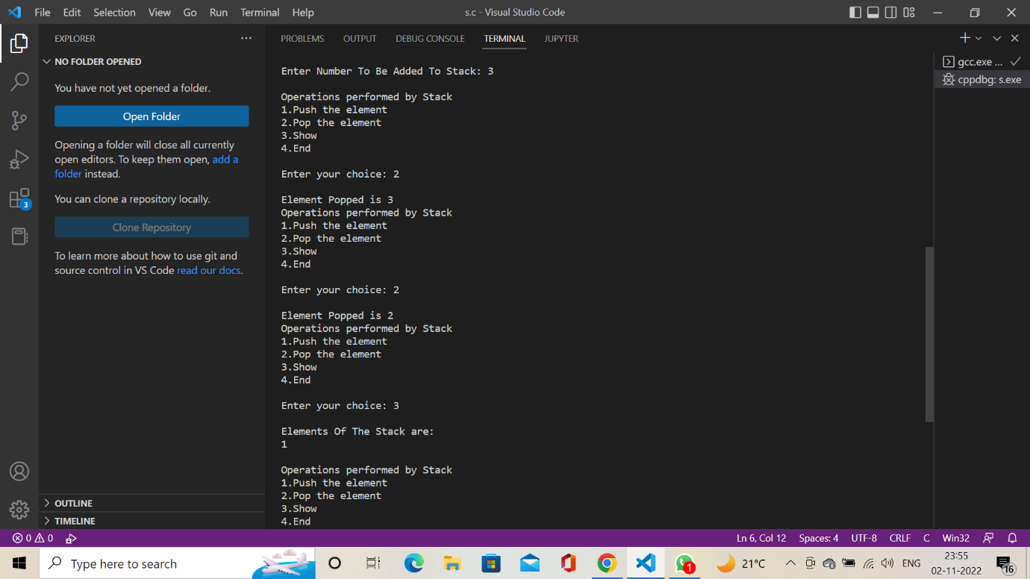

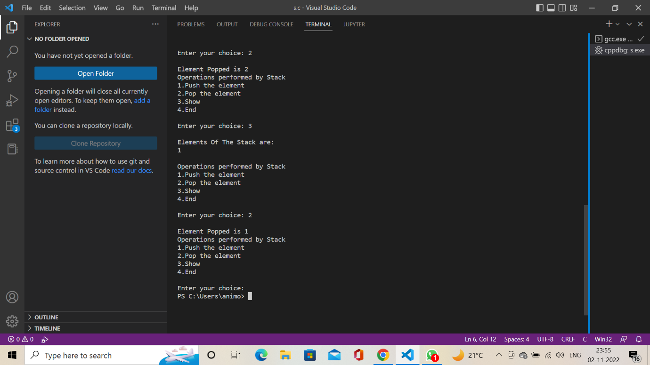

**Exp.2.** Kindly use the stack data structure to reverse a number/string and if the number is a palindrome, print that number/string.

#include <stdio.h>

void numberStack(int arr[10]) {

    int remainder, num;

    int top = -1, copy, count=0, choice;

    printf("\nEnter the number : ");

    scanf("%d", &num);

    copy = num;

    //Pushing all the elements in the stack

    while (num != 0) {

        remainder = num % 10;

        arr[top] = remainder;

        num /= 10;

        top++;

    }

    num = copy;

    top--;

    while(num != 0) {

        remainder = num % 10;

        if(remainder == arr[top--]) {}

        else {

            count = 1;

        }

        num /= 10;

    }

    if(count == 1) {

        printf("\nThe number that you have entered is NOT a PALINDROME\n");

    }

    else {

        printf("\nThe number that you have entered is a PALINDROME\n");

    }

}

void stringStack(int arr[10]) {

    char str[20], i = 0, count = 0;

    printf("\nEnter the string : ");

    scanf("%s ",str);

        printf("entered -- %c", str[0]);

    //Pushing all the elements in the stack

    while (str[i] != '\0') {

        printf("entered -- %c", str[i]);

        arr[i] = str[i++];

    }

    i = 0;

    while(str[i] != '\0') {

        if(arr[i] == str[i]) {}

        else {

            count = 1;

        }

    }

    if(count == 1) {

        printf("\nThe string that you have entered is NOT a PALINDROME\n");

    }

    else {

        printf("\nThe string that you have entered is a PALINDROME\n");

    }

}

int main() {

    int top = -1, copy, count=0, choice;

    int num, remainder;

    int stackarr[10];

    printf("\n1. String\n2. Number\n");

    printf("\nChoose One : ");

    scanf("%d", &choice);

    switch(choice) {

        case 1:

            stringStack(stackarr);

            break;

        case 2:

            numberStack(stackarr);

            break;

        default:

            break;

    }

    return 0;

}

**Output:**

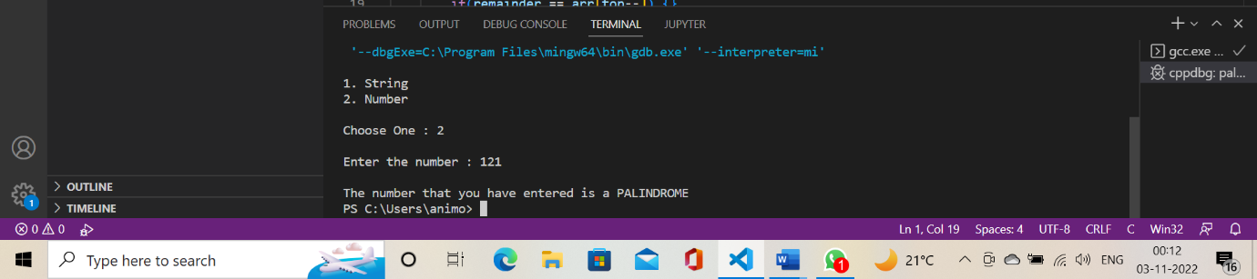

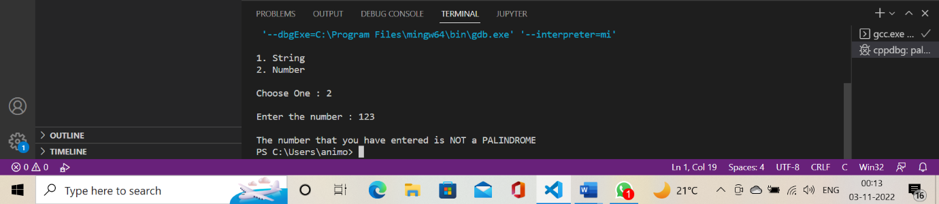

**Assignment: 9**

**EXP.** WAP to implement the following scenarios.

1. Create Queue
2. Perform Enqueue and Deque operations on Queue.
3. Traverse the queue and print its element.
4. Print underflow and overflow when desired conditions are not met.
5. Reverse the elements of Queue using recursion.

**CODING:**

#include <stdio.h>

# define SIZE 20

void enqueue();

void dequeue();

void show();

int inp_arr[SIZE];

int Rear = - 1;

int Front = - 1;

main()

{

    int a;

    while (1)

    {

        printf("1.Enqueue Operation\n");

        printf("2.Dequeue Operation\n");

        printf("3.Display the Queue\n");

        printf("4.Exit\n");

        printf("Enter your choice of operations : ");

        scanf("%d", &a);

        switch (a)

        {

            case 1:

            enqueue();

            break;

            case 2:

            dequeue();

            break;

            case 3:

            show();

            break;

            case 4:

            exit(0);

            default:

            printf("Incorrect choice \n");

        }

    }

}

void enqueue()

{

    int insert_item;

    if (Rear == SIZE - 1)

       printf("Overflow \n");

    else

    {

        if (Front == - 1)

        Front = 0;

        printf("Element to be inserted in the Queue\n : ");

        scanf("%d", &insert_item);

        Rear = Rear + 1;

        inp_arr[Rear] = insert_item;

    }

}

void dequeue()

{

    if (Front == - 1 || Front > Rear)

    {

        printf("Underflow \n");

        return ;

    }

    else

    {

        printf("Element deleted from the Queue: %d\n", inp_arr[Front]);

        Front = Front + 1;

    }

}

void show()

{

    if (Front == - 1)

        printf("Empty Queue \n");

    else

    {

        printf("Queue: \n");

        for (int i = Front; i <= Rear; i++)

            printf("%d ", inp_arr[i]);

        printf("\n");

    }

}

**OUTPUT:**

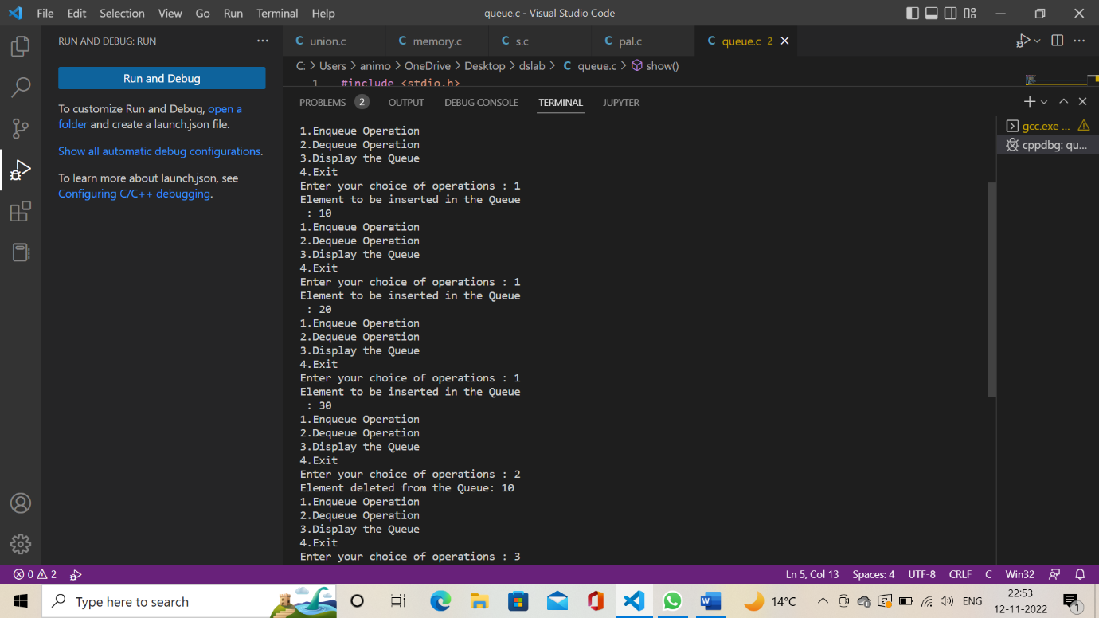

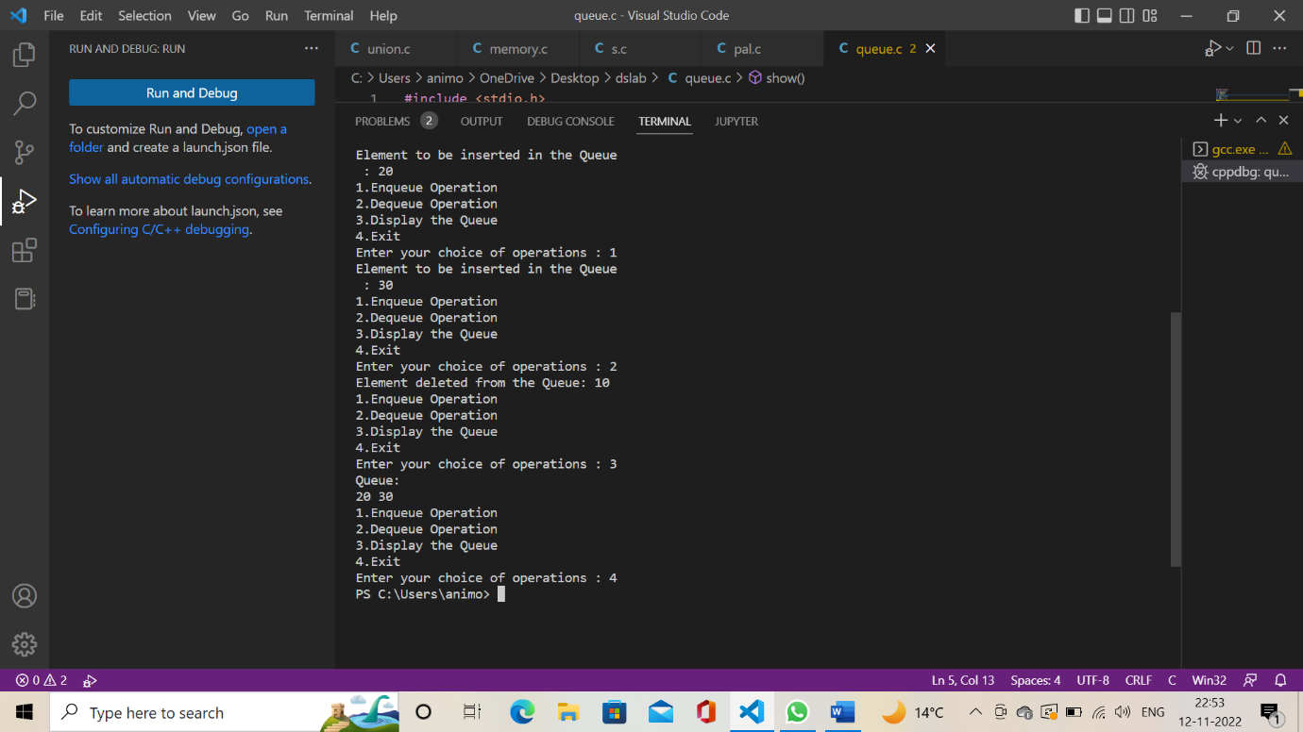

**Assignment: 10**

**EXP .** WAP to populate an array of 'n' elements using a random function. Share the time complexity for all the experiments, n should be large enough to see the difference in execution.

1. Implement Insertion sort in the above data set.
2. Implement Selection sort in the above data set.
3. Implement Merge Sort using the above dataset.
4. Implement Quicksort in the above data set.

**CODING:**

#include <stdio.h>

#include <stdlib.h>

#include <time.h>

double time1, timedif;

void random(int array[], int length, int max)

{

    for (int i = 0; i < length; i++)

        array[i] = (rand() % max) + 1;

}

void printArray(int array[], int size_arr)

{

    for (int i = 0; i < size_arr; ++i)

    {

        printf("%d\n ", array[i]);

    }

    printf("\n");

}

void swap(int *a, int *b)

{

    int temp = *a;

    *a = *b;

    *b = temp;

}

void selectionSort(int array[], int size_arr)

{

    for (int step = 0; step < size_arr - 1; step++)

    {

        int min_idx = step;

        for (int i = step + 1; i < size_arr; i++)

        {

            if (array[i] < array[min_idx])

                min_idx = i;

        }

        swap(&array[min_idx], &array[step]);

    }

}

void insertionSort(int array[], int size_arr)

{

    for (int step = 1; step < size_arr; step++)

    {

        int key = array[step];

        int j = step - 1;

        while (key < array[j] && j >= 0)

        {

            array[j + 1] = array[j];

            --j;

        }

        array[j + 1] = key;

    }

}

int partition(int array[], int low, int high)

{

    int pivot = array[high];

    int i = (low - 1);

    for (int j = low; j < high; j++)

    {

        if (array[j] <= pivot)

        {

            i++;

            swap(&array[i], &array[j]);

        }

    }

    swap(&array[i + 1], &array[high]);

    return (i + 1);

}

void quickSort(int array[], int low, int high)

{

    if (low < high)

    {

        int pi = partition(array, low, high);

        quickSort(array, low, pi - 1);

        quickSort(array, pi + 1, high);

    }

}

int main(void)

{

    srand(time(NULL));

    int size_arr;

    int choice;

    int array[size_arr];

    printf("Please enter the number of random numbers to be genrated:\n");

    scanf("%d", &size_arr);

    random(array, size_arr, 1000000000);

    for (int i = 0; i < size_arr; i++)

    {

        printf("a[%d]=%d\n", i, array[i]);

    }

    printf("\n\t 1.selection sort\n\t 2.insertion sort\n\t 3.quick sort\n\t 4.EXIT");

    do

    {

        printf("\n Enter the Choice:");

        scanf("%d", &choice);

        switch (choice)

        {

        case 1:

        {

            time1 = (double)clock();

            time1 = time1 / CLOCKS_PER_SEC;

            selectionSort(array, size_arr);

            printf("Sorted array for selection sort:\n");

            printArray(array, size_arr);

            timedif = (((double)clock()) / CLOCKS_PER_SEC) - time1;

            printf("The elapsed time is %f seconds\n", timedif);

            break;

        }

        case 2:

        {

            time1 = (double)clock();

            time1 = time1 / CLOCKS_PER_SEC;

            insertionSort(array, size_arr);

            printf("Sorted arrayfor insertion sort:\n");

            printArray(array, size_arr);

            timedif = (((double)clock()) / CLOCKS_PER_SEC) - time1;

            printf("The elapsed time is %f seconds\n", timedif);

            break;

        }

        case 3:

        {

            time1 = (double)clock();

            time1 = time1 / CLOCKS_PER_SEC;

            quickSort(array, 0, size_arr - 1);

            printf("Sorted array for quick sort: \n");

            printArray(array, size_arr);

            timedif = (((double)clock()) / CLOCKS_PER_SEC) - time1;

            printf("The elapsed time is %f seconds\n", timedif);

            break;

        }

        case 4:

        {

            printf("\n\t EXIT POINT ");

            break;

        }

        default:

        {

            printf("\n\t Please enter a Valid Choice(1/2/3/4)");

        }

        }

    } while (choice != 4);

    return 0;

}

**OUTPUT:** 200 random number array.

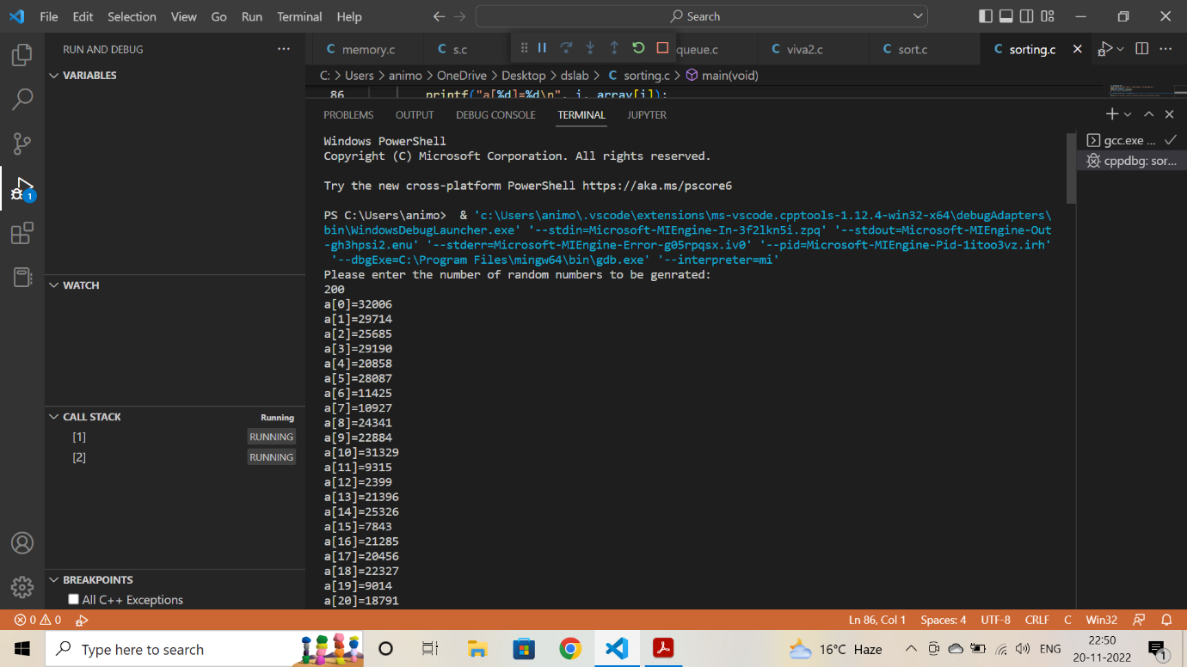

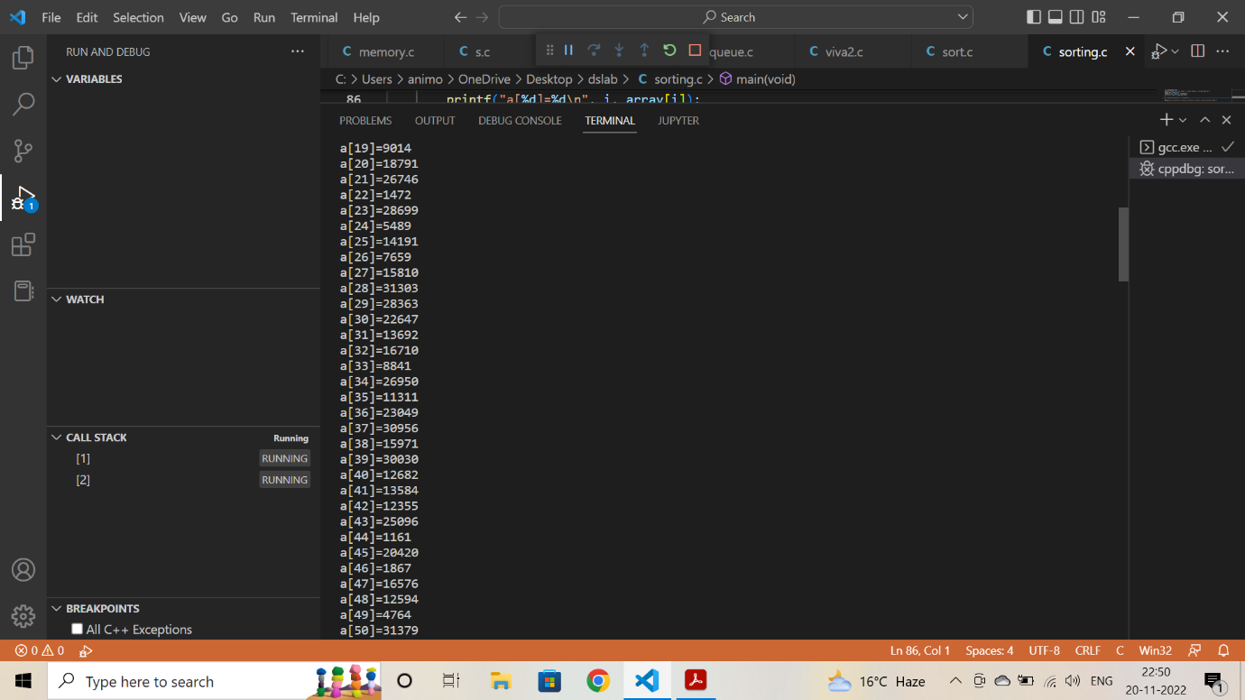

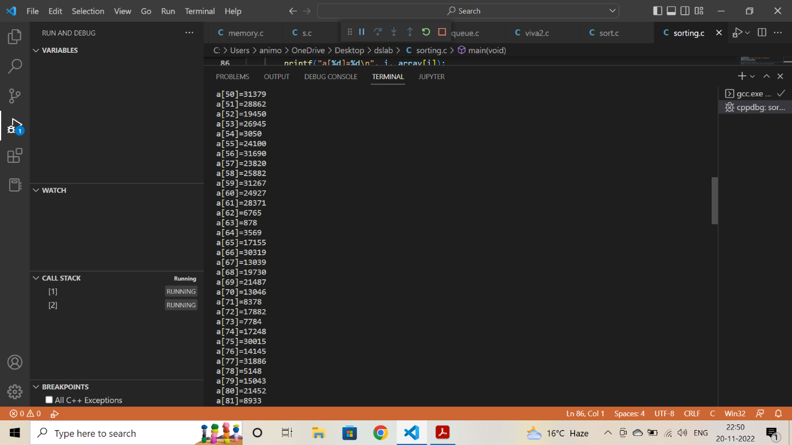

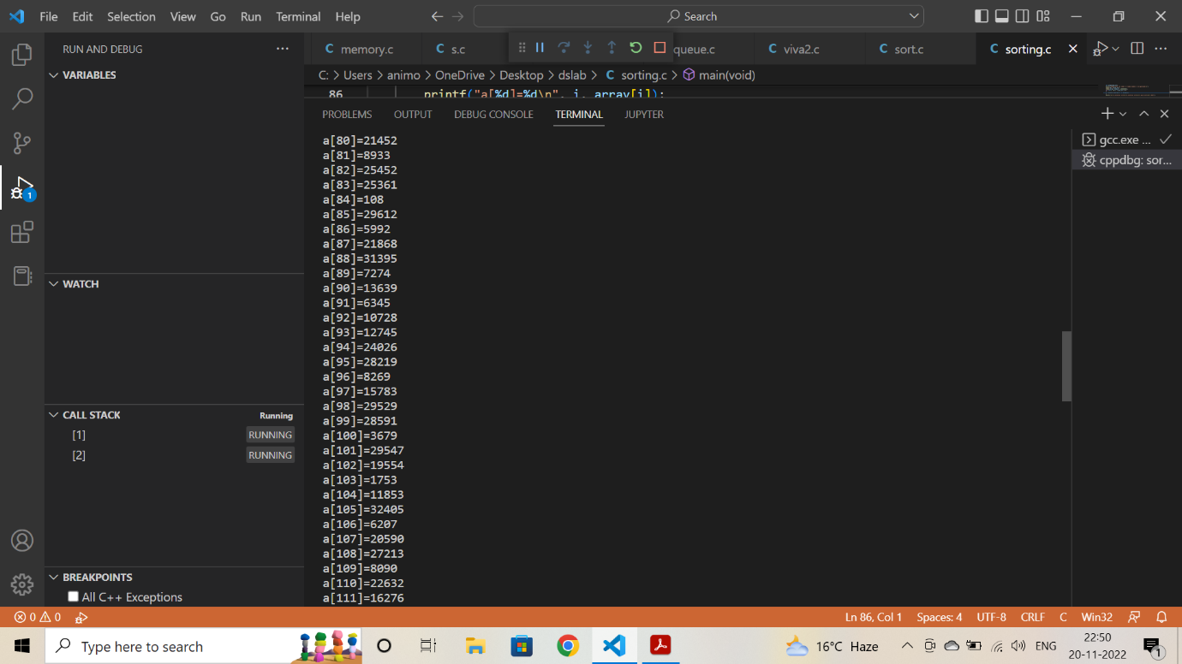

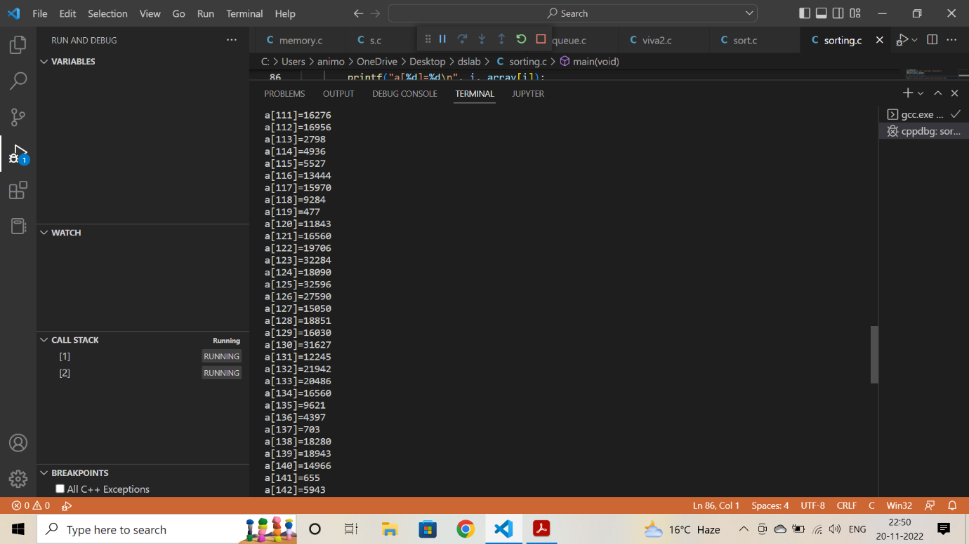

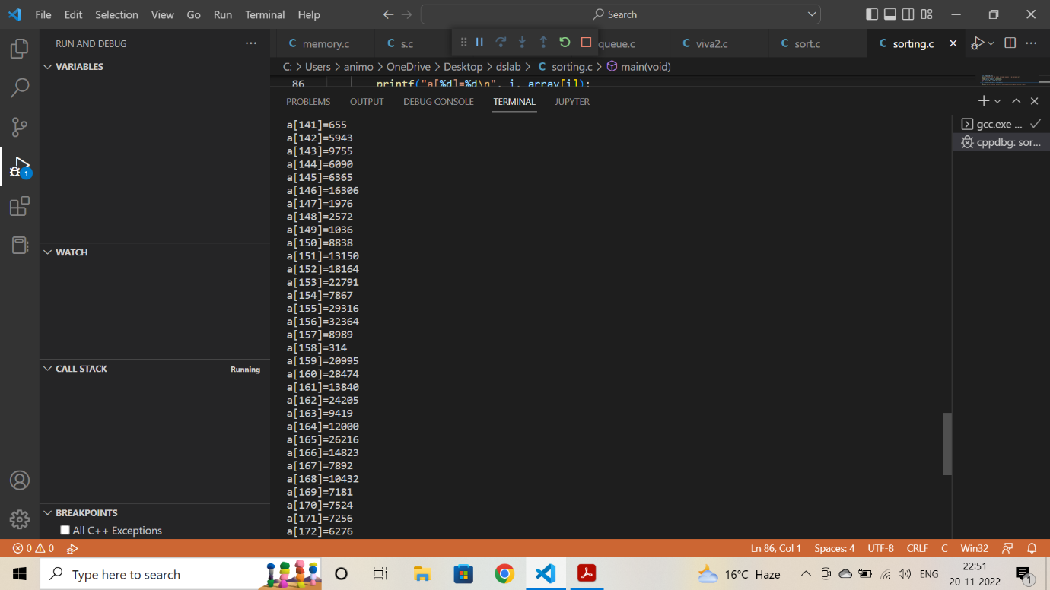

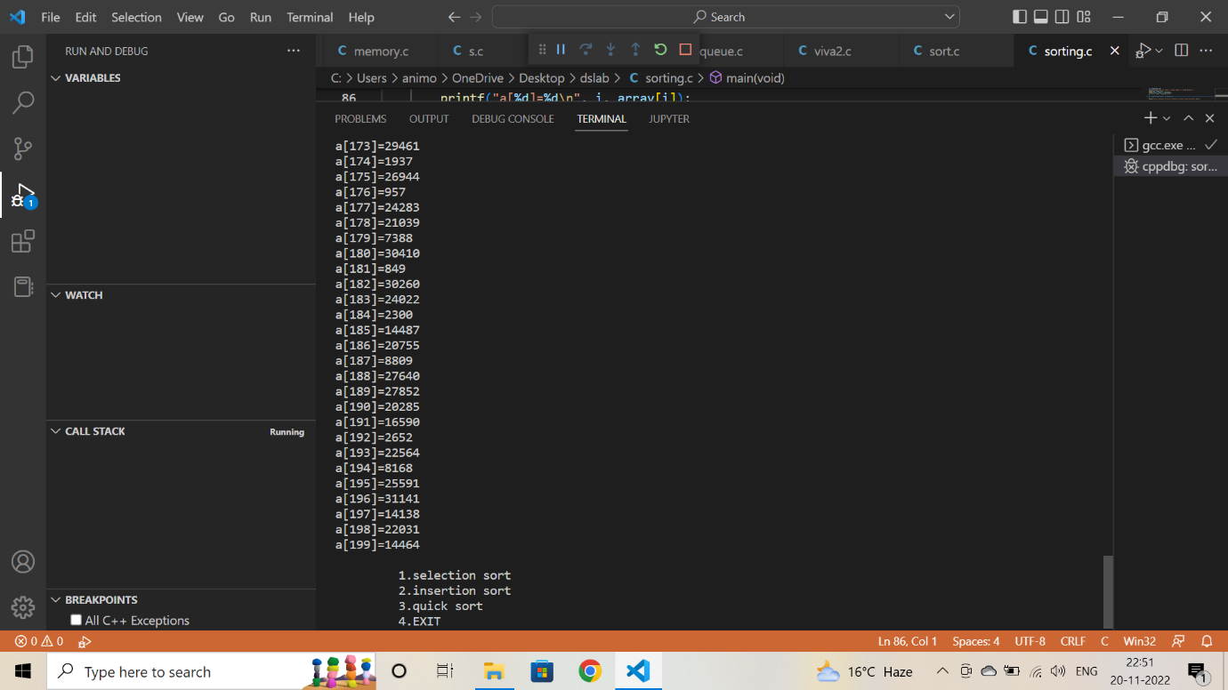

1. **Selection sort**

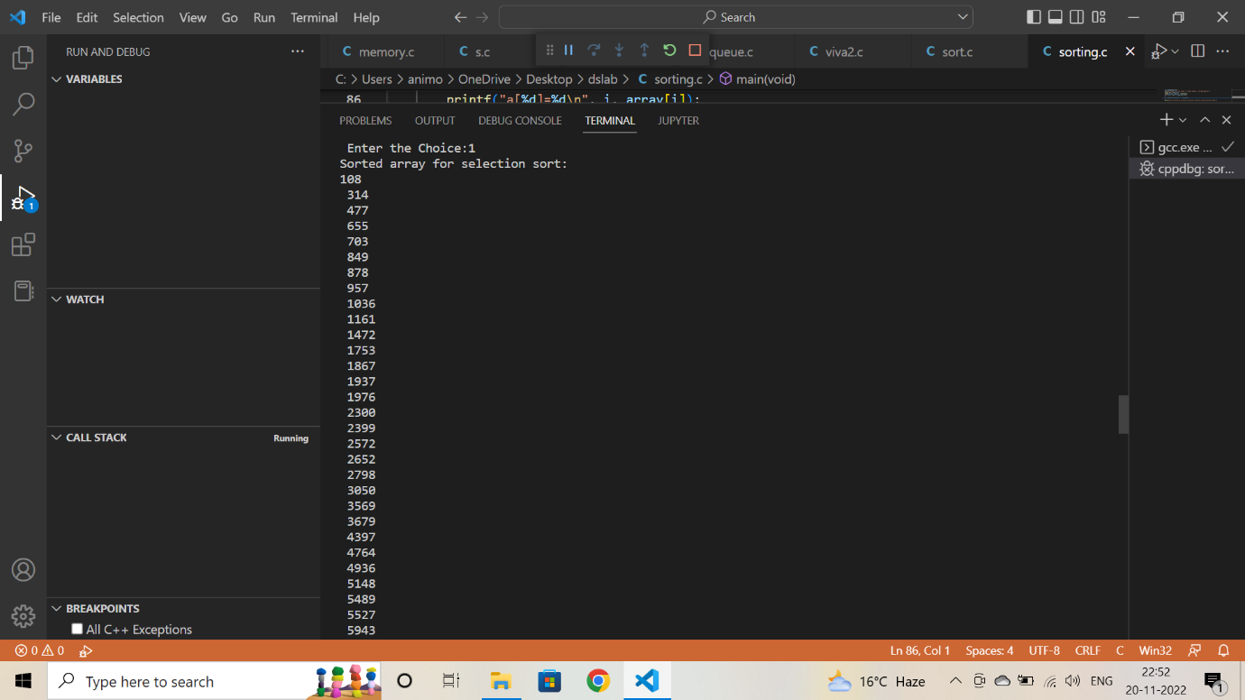

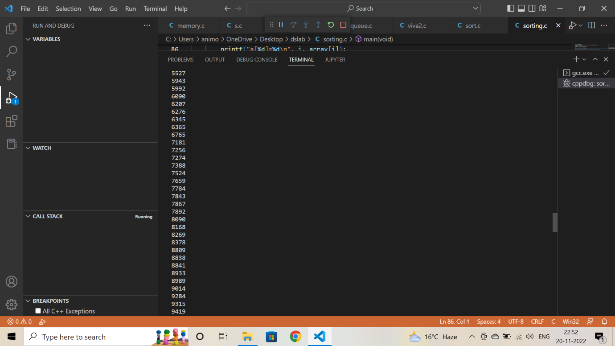 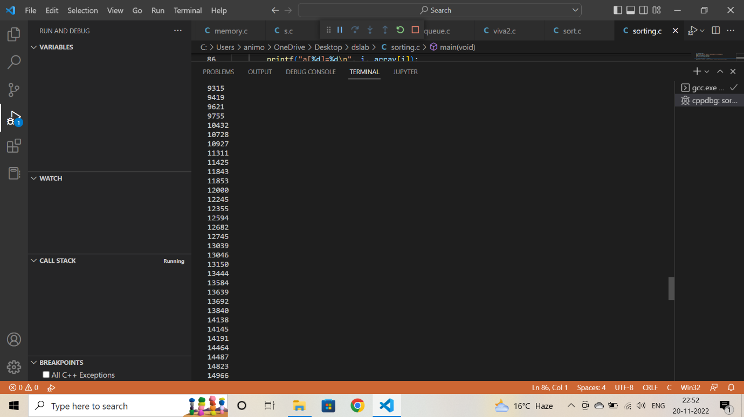

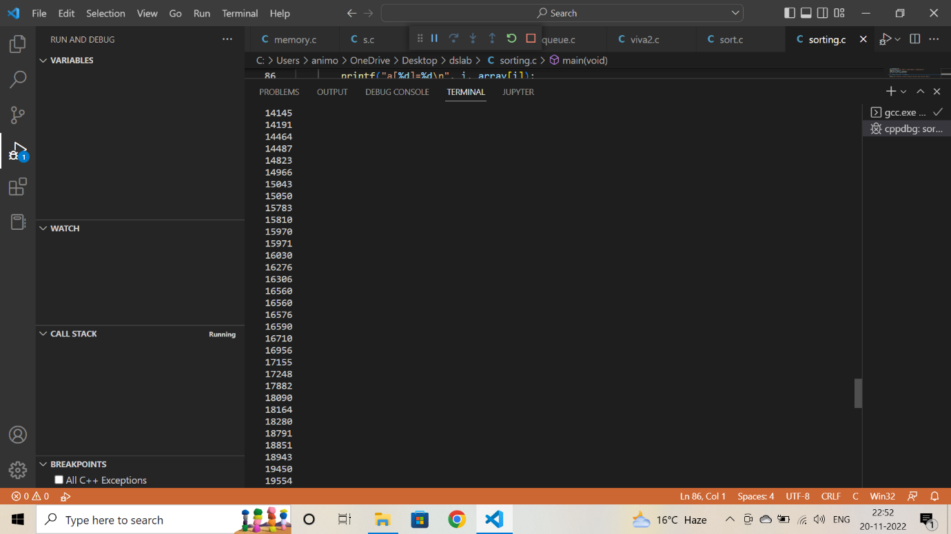

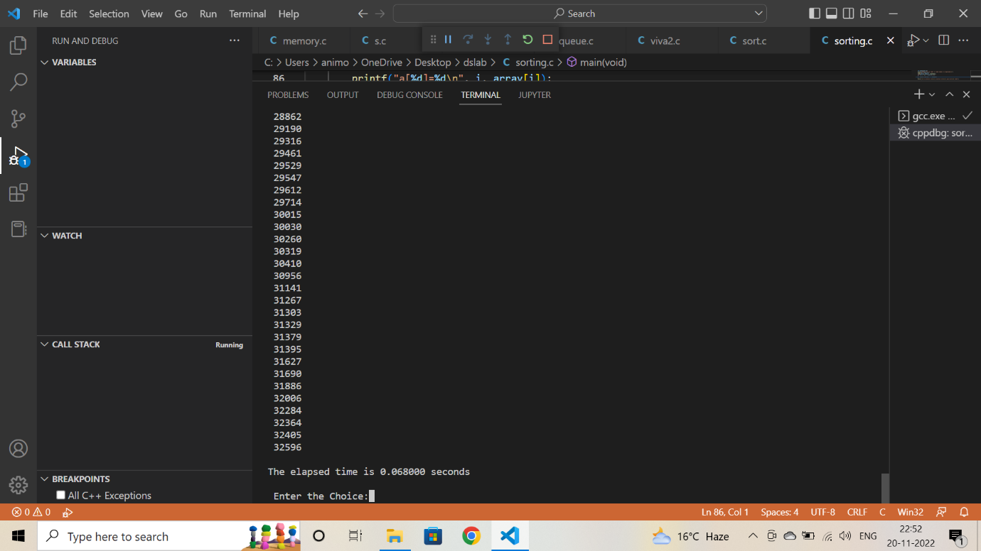

**Time elapsed 0.068000 second.**

1. **Insertion sort**

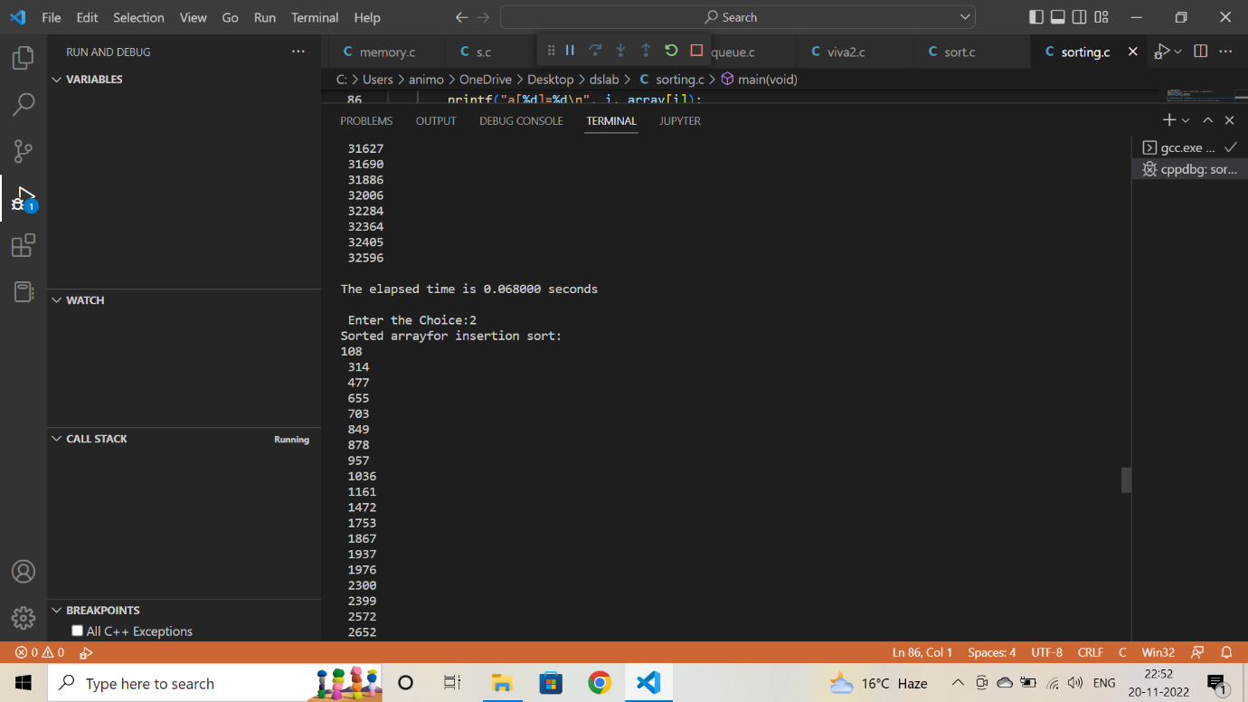

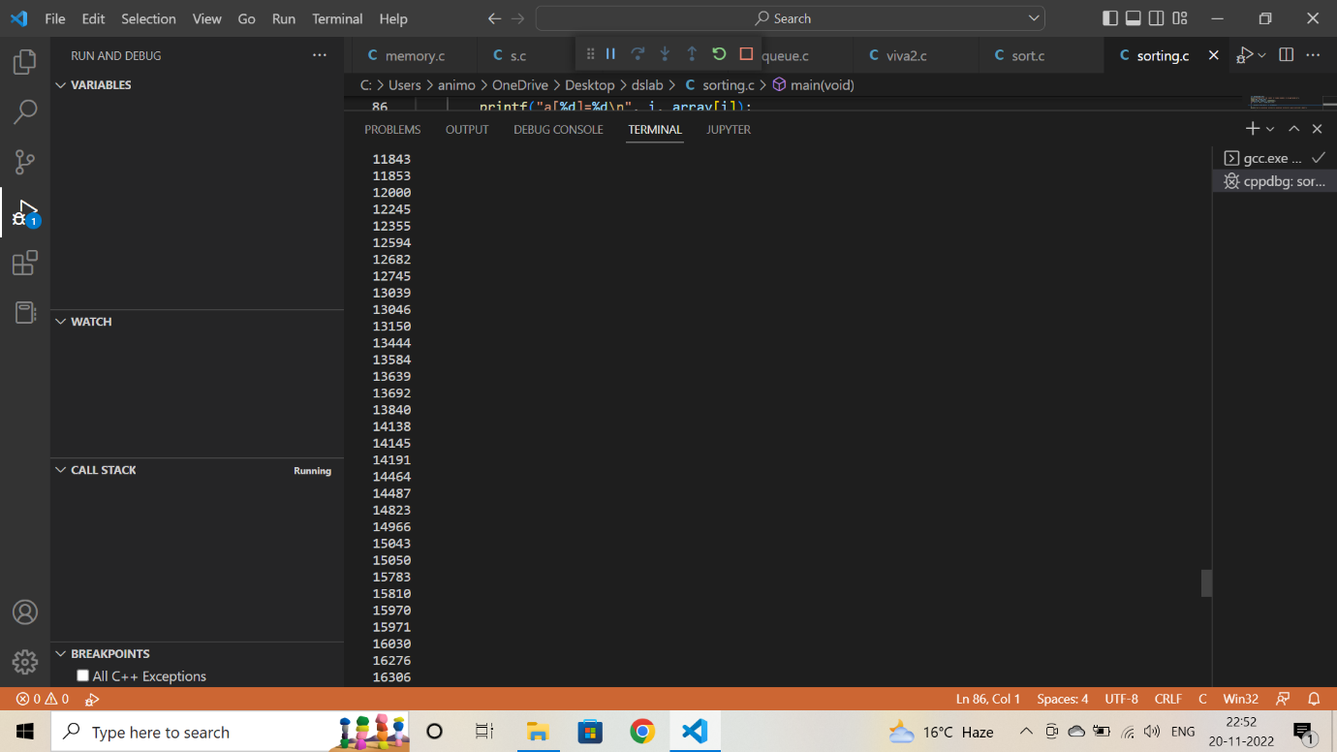 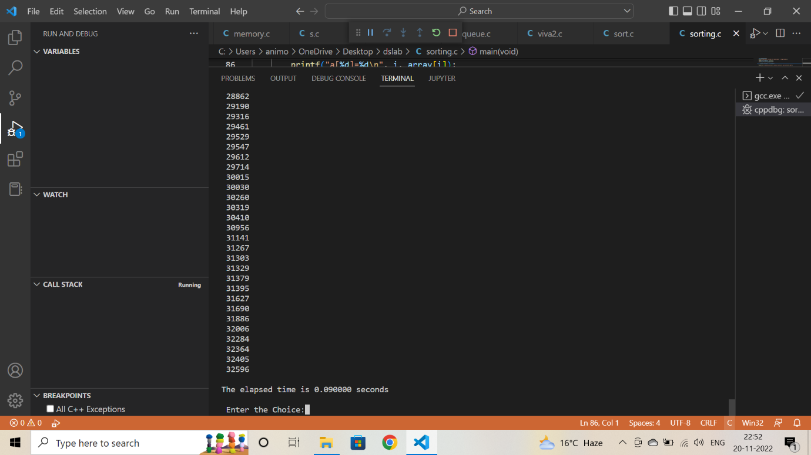

**Time elapsed 0.090000 second.**

1. **Quicksort**

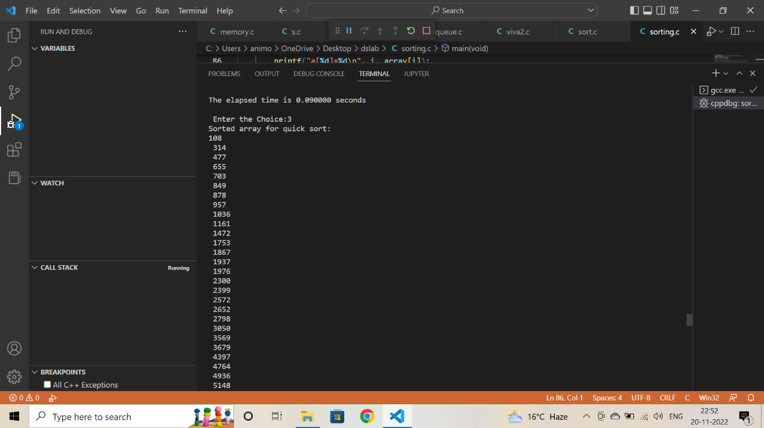

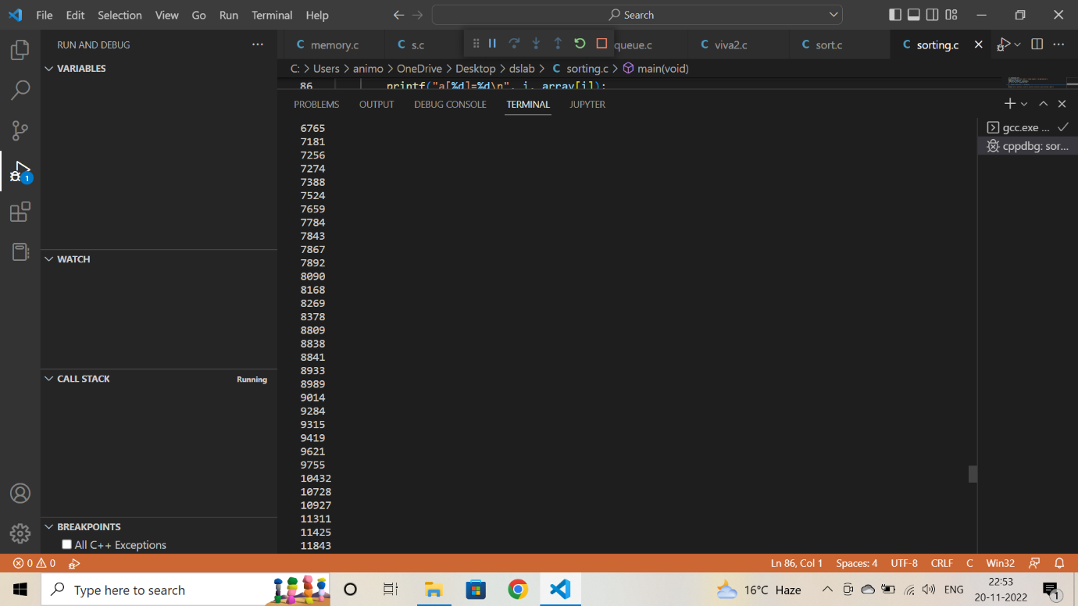

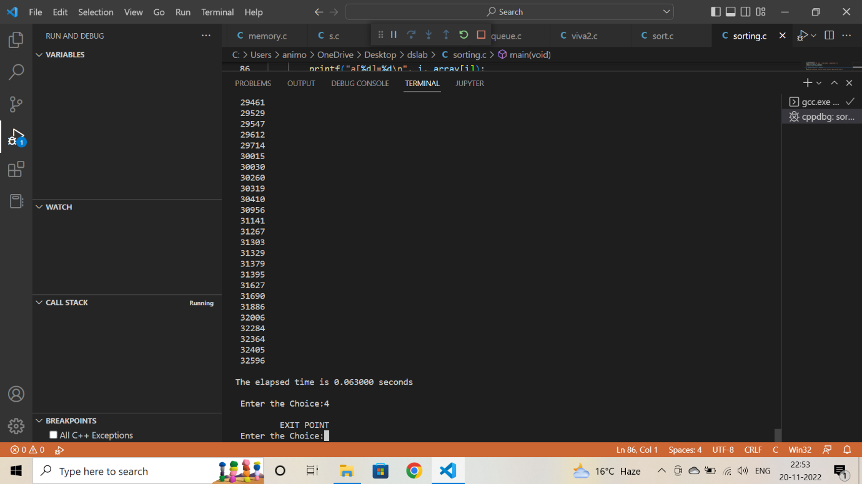

**Time elapsed 0.063000 second.**

**Assignment: 11**

**EXP.**Kindly use the following link for making submission related to binary tree.

1. WAP to create a tree with a given inputs from user.

2. WAP to write the inorder,pre-order and post order traversal.

3. WAP to insert element at desired locations.

4. WAP to delete the elements from tree, take input from the user for deleting the entries from trees.

5. WAP to check for the key elements in node, if the node has multiple of 3, replace it with 5 or if Key elements has any vowel element, replace those with 'Z'.

**Coding:**

#include <stdio.h>

#include <stdlib.h>

struct tree_node

{

    int val;

    char v;

    struct tree_node *left;

    struct tree_node *right;

};

typedef struct tree_node tnode;

struct tree

{

    tnode *root;

};

typedef struct tree tree;

tnode *create_node(int ele, char e)

{

    tnode *temp = (tnode *)malloc(sizeof(tnode));

    temp->val = ele;

    temp->v = e;

    temp->left = NULL;

    temp->right = NULL;

    return temp;

}

tree *create_tree()

{

    tree *bt = (tree *)malloc(sizeof(tree *));

    bt->root = NULL;

    printf("Tree created!\n");

    return bt;

}

void insert_wherever(tree *bt, tnode *e)

{

    int choice;

    int flag = 0;

    if (bt->root == NULL)

    {

        bt->root = e;

        return;

    }

    else

    {

        tnode *temp = bt->root;

        while (temp != NULL)

        {

            printf("Press 1 to move left\n");

            printf("Press 2 to move right\n");

            scanf("%d", &choice);

            switch (choice)

            {

            case 1:

                if (temp->left == NULL)

                {

                    temp->left = create_node(e->val, e->v);

                    flag = 1;

                    break;

                }

                else

                {

                    temp = temp->left;

                }

                break;

            case 2:

                if (temp->right == NULL)

                {

                    temp->right = create_node(e->val, e->v);

                    flag = 1;

                    break;

                }

                else

                {

                    temp = temp->right;

                }

                break;

            default:

                printf("Wrong choice!\n");

                break;

            }

            if (flag == 1)

            {

                break;

            }

        }

    }

    printf("Element Inserted!\n");

}

tnode *find(tree *bt, tnode *root, int ele)

{

    tnode *temp;

    if (root == NULL)

    {

        return NULL;

    }

    else if (root->val == ele)

    {

        return root;

    }

    else

    {

        temp = find(bt, root->left, ele);

        if (temp != NULL)

        {

            return temp;

        }

        temp = find(bt, root->right, ele);

        return temp;

    }

}

tnode *rightmost_node(tree *bt)

{

    tnode *temp = bt->root;

    tnode *t;

    while (temp->right->right != NULL)

    {

        temp = temp->right;

    }

    t = temp->right;

    temp->right = NULL;

    return t;

}

void delete_node(tree *bt, int ele)

{

    tnode *del_node = find(bt, bt->root, ele);

    tnode *deep_node = rightmost_node(bt);

    if (del_node == deep_node)

    {

        free(deep_node);

        free(del_node);

    }

    else if (del_node == NULL)

    {

        printf("Cannot delete!\n");

        return;

    }

    else

    {

        del_node->val = deep_node->val;

        del_node->v = deep_node->v;

        free(deep_node);

    }

    printf("Node deleted!\n");

}

void inorder_traversal(tree *bt, tnode *root)

{

    if (root == NULL)

    {

        return;

    }

    else

    {

        inorder_traversal(bt, root->left);

        printf("{%d, %c} ", root->val, root->v);

        inorder_traversal(bt, root->right);

    }

}

void preorder_traversal(tree *bt, tnode *root)

{

    if (root == NULL)

    {

        return;

    }

    else

    {

        printf("{%d, %c} ", root->val, root->v);

        inorder_traversal(bt, root->left);

        inorder_traversal(bt, root->right);

    }

}

void postorder_traversal(tree *bt, tnode *root)

{

    if (root == NULL)

    {

        return;

    }

    else

    {

        inorder_traversal(bt, root->left);

        inorder_traversal(bt, root->right);

        printf("{%d, %c} ", root->val, root->v);

    }

}

void modify(tree *bt, tnode *root)

{

    if (root == NULL)

    {

        return;

    }

    else

    {

        modify(bt, root->left);

        if ((root->v == 'a') || (root->v == 'e') || (root->v == 'i') || (root->v == 'o') || (root->v == 'u') || (root->v == 'A') || (root->v == 'E') || (root->v == 'I') || (root->v == 'O') || (root->v == 'U'))

        {

            root->v = 'Z';

        }

        if (root->val % 3 == 0)

        {

            root->val = 5;

        }

        modify(bt, root->right);

    }

}

void display(tree *bt, tnode *ptr, int level)

{

    int i;

    if (ptr != NULL)

    {

        display(bt, ptr->right, level + 1);

        printf("\n");

        if (ptr == bt->root)

        {

            printf("Root->:  ");

        }

        else

        {

            for (i = 0; i < level; i++)

            {

                printf("       ");

            }

        }

        printf("{%d, %c}", ptr->val, ptr->v);

        display(bt, ptr->left, level + 1);

    }

    printf("\n");

}

void displaycall(tree *bt)

{

    if (bt->root == NULL)

    {

        printf("No nodes present....\n");

        return;

    }

    display(bt, bt->root, 1);

}

int main()

{

    int choice = 0;

    tree *bt;

    tnode *n;

    int ele;

    char e;

    while (choice != -1)

    {

        printf("1. Create tree.\n");

        printf("2. Insert into tree.\n");

        printf("3. Delete from tree.\n");

        printf("4. Preorder traversal.\n");

        printf("5. Inorder traversal.\n");

        printf("6. Postorder traversal.\n");

        printf("7. Modify tree.\n");

        printf("8. Display tree.\n");

        printf("9. Exit.\n");

        scanf("%d", &choice);

        switch (choice)

        {

        case 1:

            bt = create_tree();

            break;

        case 2:

            printf("Enter int value to be inserted:\n");

            scanf("%d", &ele);

            printf("Enter char value to be inserted:\n");

            scanf("\n%c", &e);

            n = create_node(ele, e);

            insert_wherever(bt, n);

            break;

        case 3:

            printf("Enter int value for node to be deleted:\n");

            scanf("%d", &ele);

            delete_node(bt, ele);

            break;

        case 4:

            printf("Preorder traversal of tree:\n");

            preorder_traversal(bt, bt->root);

            printf("\n");

            break;

        case 5:

            printf("Inorder traversal of tree:\n");

            inorder_traversal(bt, bt->root);

            printf("\n");

            break;

        case 6:

            printf("Postorder traversal of tree:\n");

            postorder_traversal(bt, bt->root);

            printf("\n");

            break;

        case 7:

            modify(bt, bt->root);

            printf("Tree modified!\n");

            break;

        case 8:

            displaycall(bt);

            break;

        case 9:

            printf("Exiting...\n");

            break;

        default:

            printf("Wrong choice!!\n");

            break;

        }

    }

    return 0;

}

**Output:**

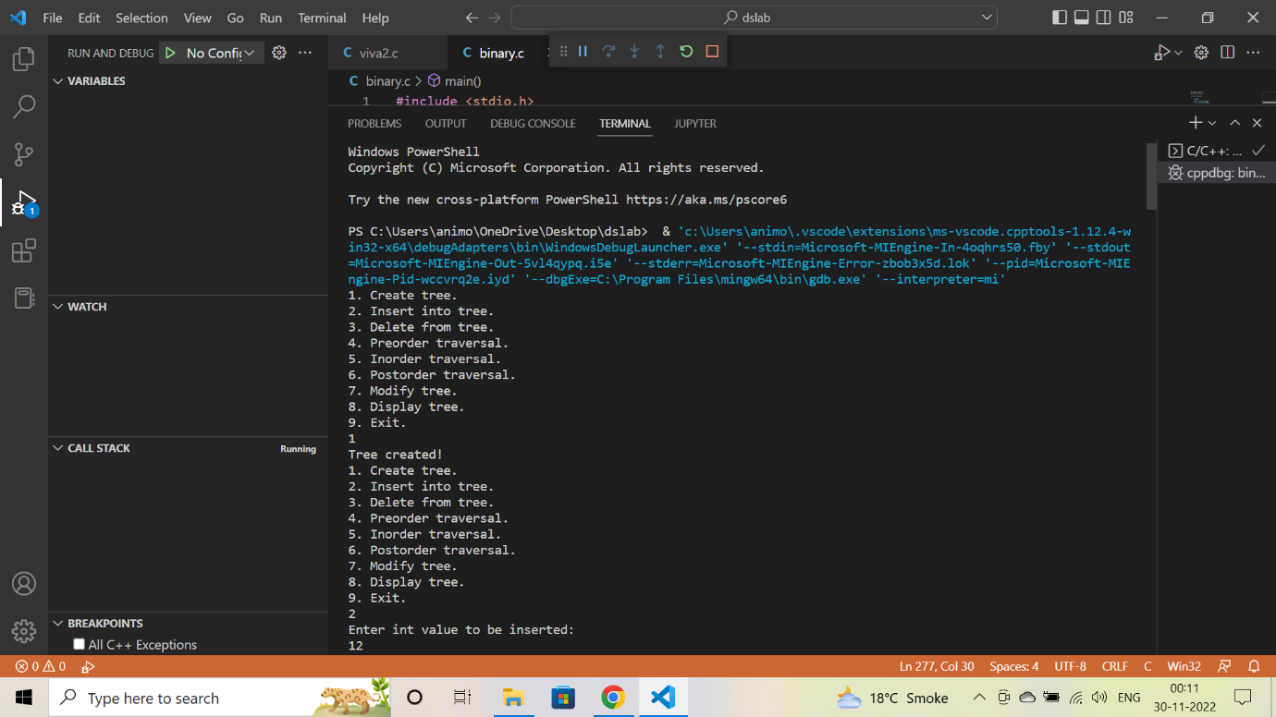

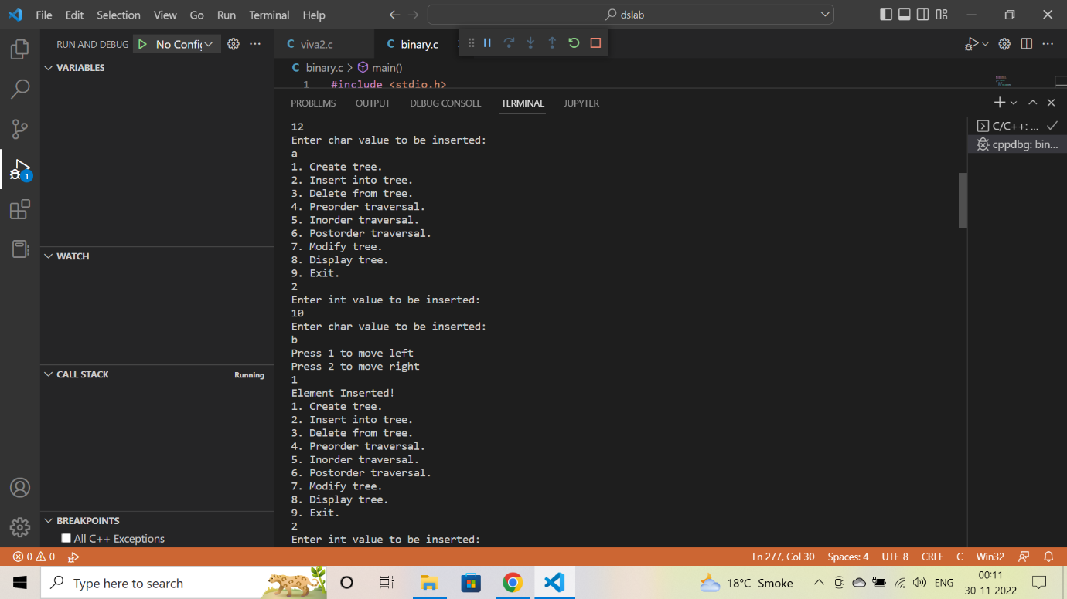

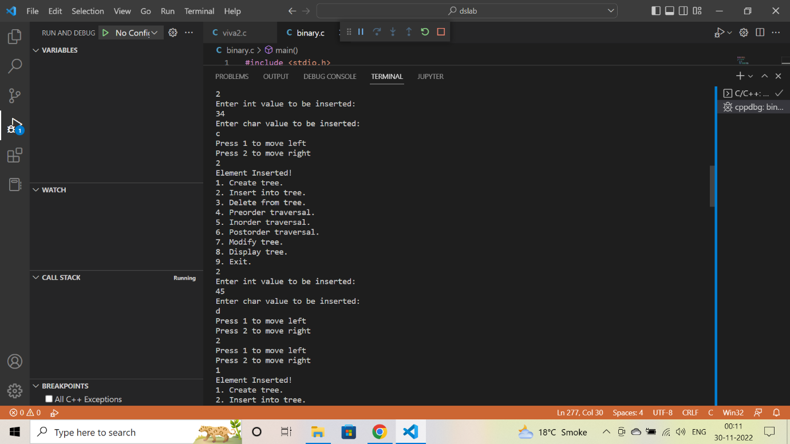

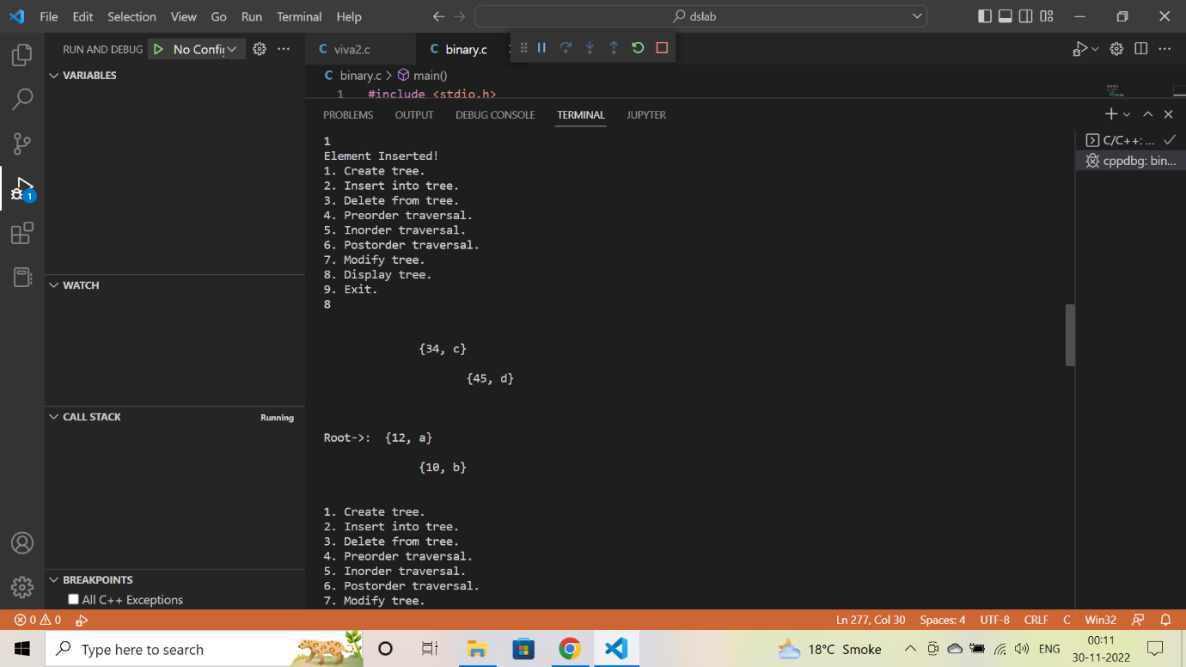

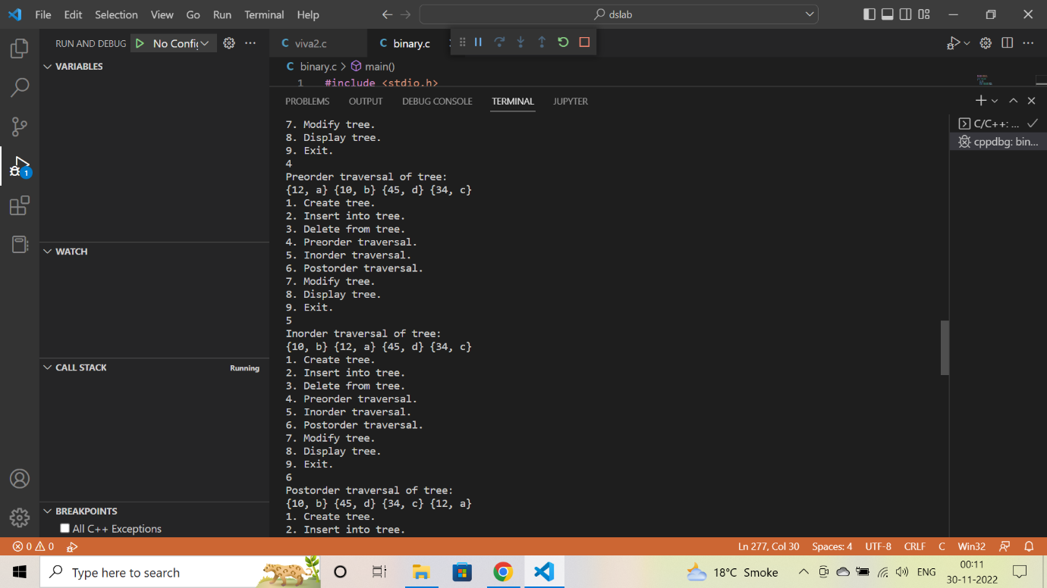

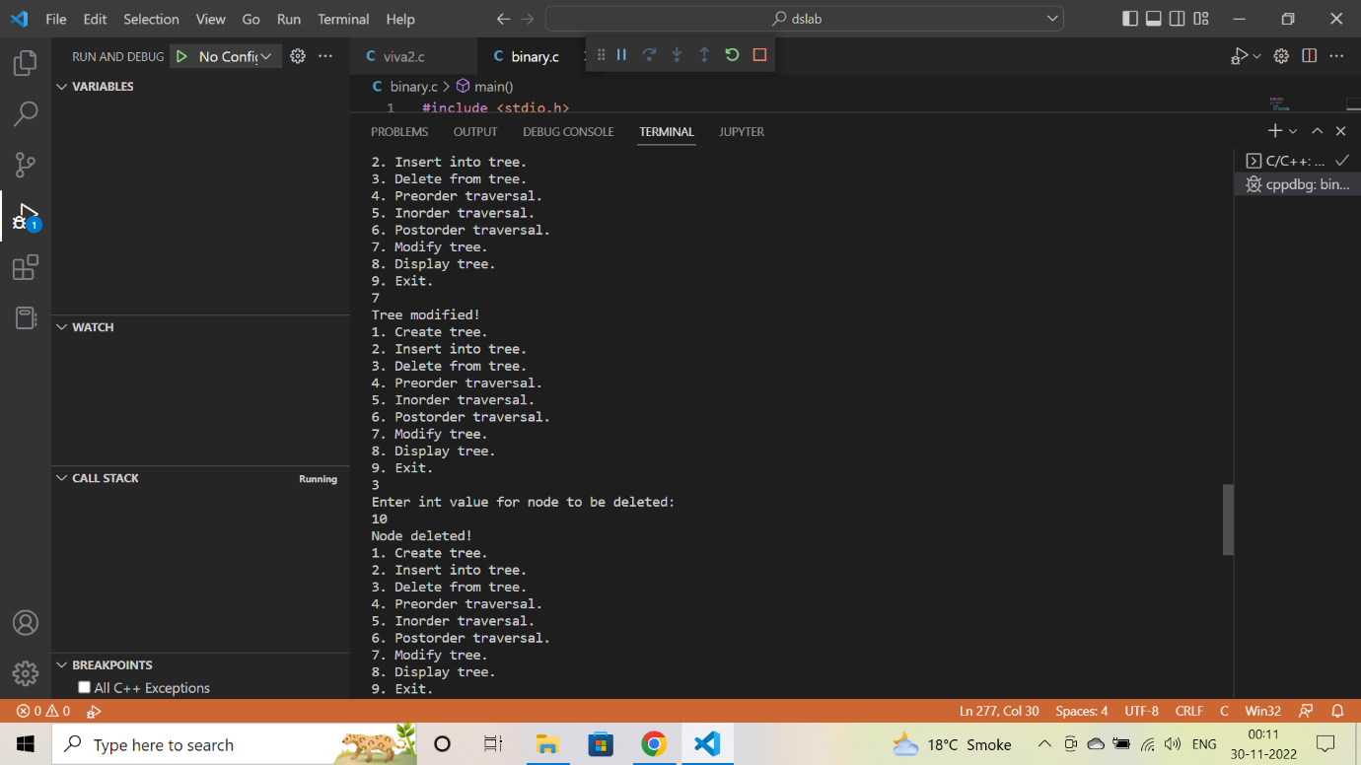

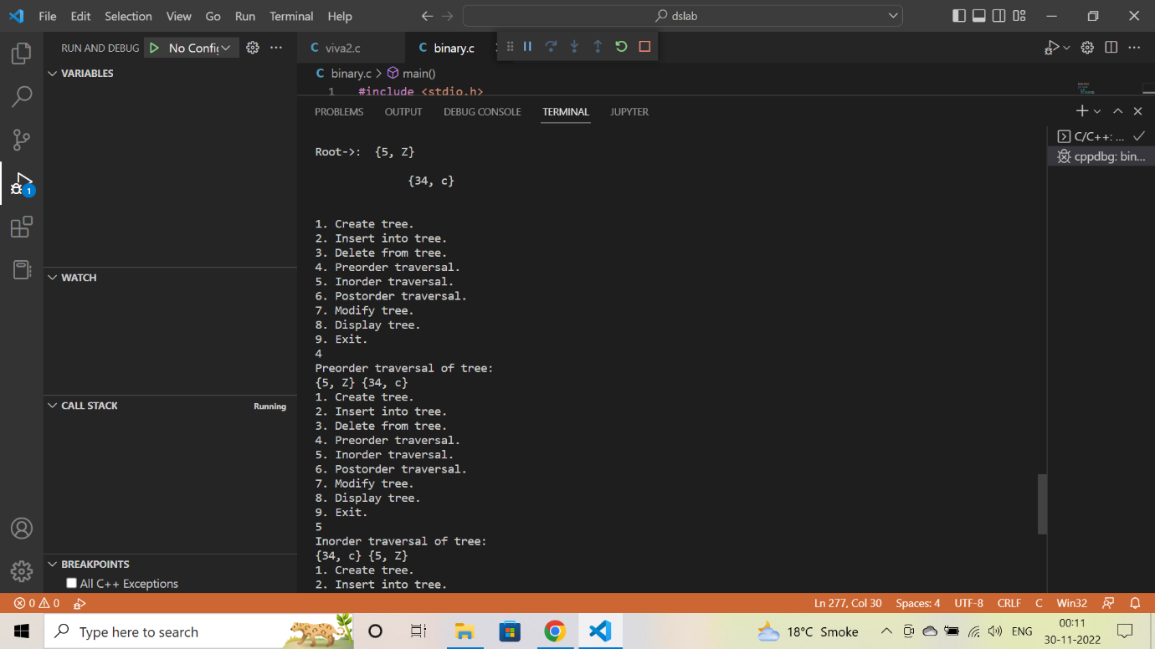

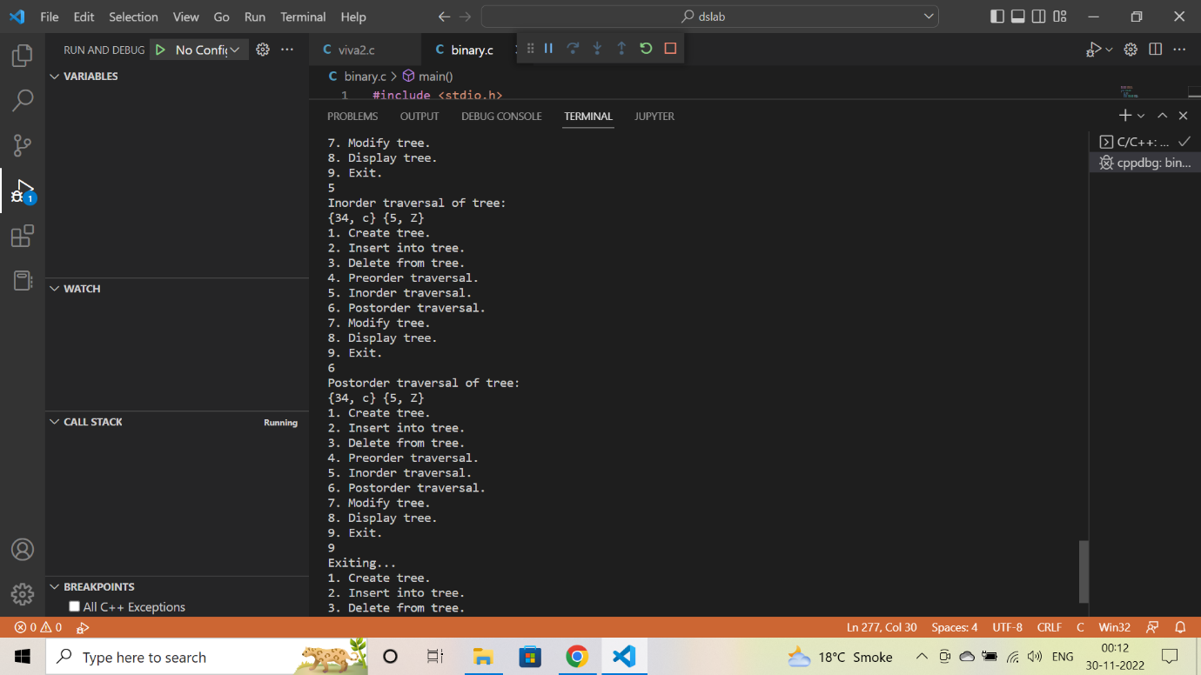

**Assignment: 12**

**EXP 1. WAP to check for the smallest and largest subarrays in an array whose sum is 15. Generate the array randomly. Implement hashing and linear probing to avoid collision in a given set of keys.**

**Coding:**

#include<stdio.h>

#include<stdlib.h>

#include<time.h>

#define MAX_SIZE 10

#define SUM_VALUE 15

int arr[MAX_SIZE], table[MAX_SIZE];

int random_num()

{

    return (rand()%20);

}

void initializeTable()

{

    for(int i=0; i<MAX_SIZE; i++)

        table[i] = -1;

}

int hashFn(int key)

{

    return key % MAX_SIZE;

}

int linearProbe(int key)

{

    int i = 0;

    while(1)

    {

        int index = (hashFn(key) + i) % MAX_SIZE;

        if(table[index] == -1)

            return index;

        i++;

    }

}

void insert(int key)

{

    int index = hashFn(key);

    if(table[index] == -1)

        table[index] = key;

    else

        table[linearProbe(key)] = key;

}

void displayArray(int arr[], int n)

{

    for(int i=0; i<n; i++)

        printf("%d ", arr[i]);

    printf("\n");

}

void smallestSubarray()

{

    int min_len = MAX_SIZE;

    int start = 0, end = 0;

    int sum = 0;

    for(int i=0; i<MAX_SIZE; i++)

        sum += arr[i];

    if(sum == SUM_VALUE)

    {

        min_len = MAX_SIZE;

        start = 0;

        end = MAX_SIZE - 1;

    }

    else

    {

        sum = 0;

        int i = 0;

        while(i<MAX_SIZE)

        {

            sum += arr[i];

            if(sum > SUM_VALUE)

            {

                int j = i-1;

                while(j>=0 && sum>SUM_VALUE)

                {

                    sum -= arr[j];

                    j--;

                }

                int len = i - j;

                if(len < min_len)

                {

                    min_len = len;

                    start = j + 1;

                    end = i;

                }

                i++;

            }

            else if(sum == SUM_VALUE)

            {

                int len = i + 1;

                if(len < min_len)

                {

                    min_len = len;

                    start = 0;

                    end = i;

                }

                i++;

            }

            else

                i++;

        }

    }

    printf("The smallest subarray is: ");

    displayArray(arr+start, end-start+1);

    printf("Length of the smallest subarray is: %d\n", min_len);

}

void largestSubarray()

{

    int max_len = 0;

    int start = 0, end = 0;

    int sum = 0;

    for(int i=0; i<MAX_SIZE; i++)

        sum += arr[i];

    if(sum == SUM_VALUE)

    {

        max_len = MAX_SIZE;

        start = 0;

        end = MAX_SIZE - 1;

    }

    else

    {

        sum = 0;

        int i = 0;

        while(i<MAX_SIZE)

        {

            sum += arr[i];

            if(sum > SUM_VALUE)

            {

                int j = i-1;

                while(j>=0 && sum>SUM_VALUE)

                {

                    sum -= arr[j];

                    j--;

                }

                int len = i - j;

                if(len > max_len)

                {

                    max_len = len;

                    start = j + 1;

                    end = i;

                }

                i++;

            }

            else if(sum == SUM_VALUE)

            {

                int len = i + 1;

                if(len > max_len)

                {

                    max_len = len;

                    start = 0;

                    end = i;

                }

                i++;

            }

            else

                i++;

        }

    }

    printf("The largest subarray is: ");

    displayArray(arr+start, end-start+1);

    printf("Length of the largest subarray is: %d\n", max_len);

}

int main()

{

    srand(time(0));

    printf("The array is: ");

    for(int i=0; i<MAX_SIZE; i++)

    {

        arr[i] = random_num();

        printf("%d ", arr[i]);

    }

    printf("\n");

    initializeTable();

    for(int i=0; i<MAX_SIZE; i++)

        insert(arr[i]);

    smallestSubarray();

    largestSubarray();

    return 0;

}

**Output:**

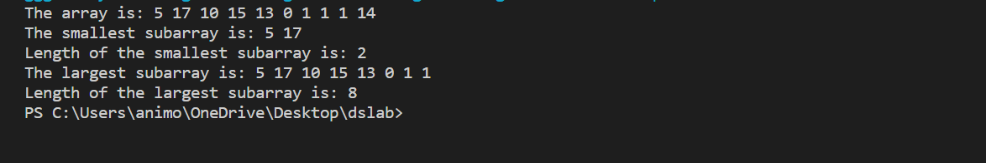

**Exp.2. WAP to implement the functionality of double hashing.**

**Coding:**

#include<stdio.h>

#include<stdlib.h>

#include<time.h>

#define TABLE_SIZE 13

struct hash{

    int value;

    int flag;

};

struct hash table[TABLE_SIZE];

int hash1(int value){

    return (value % TABLE_SIZE);

}

int hash2(int value){

    return 7 - (value % 7);

}

void insert(int value){

    int h1 = hash1(value);

    int h2 = hash2(value);

    if (table[h1].flag == 0){

        table[h1].value = value;

        table[h1].flag = 1;

    }

    else{

        int i;

        int loc;

        int h;

        for (i = 1; i < TABLE_SIZE; i++){

            loc = (h1 +  i * h2) % TABLE_SIZE;

            if (table[loc].flag == 0){

               table[loc].flag = 1;

               table[loc].value = value;

               break;

            }

        }

        if (i == TABLE_SIZE){

            printf("\nHash table full !! \n");

            return;

        }

    }

    printf("\n%d is inserted !! \n", table[h1].value);

}

int search(int value){

    int h1 = hash1(value);

    int h2 = hash2(value);

    if (table[h1].flag == 1 && table[h1].value == value){

        printf("\nElement %d found !! \n",value);

        return h1;

    }

    int i;

    int loc;

    for (i = 0; i < TABLE_SIZE; i++){

        loc = (h1 +  i * h2 ) % TABLE_SIZE;

        if (table[loc].flag == 1 && table[loc].value == value){

            printf("\nElement %d found !! \n",value);

            return loc;

        }

    }

    return -1;

}

void display(){

    printf("\nHash Table: \n");

    int i;

    for (i = 0; i < TABLE_SIZE; i++){

        printf("table[%d] = %d \n",i,table[i].value);

    }

}

int main(){

    int value,choice,i;

    srand(time(0));

    for (i = 0; i < TABLE_SIZE; i++){

        table[i].flag = 0;

        table[i].value = 0;

    }

    while(1){

        printf("\n1. Insert a value \n");

        printf("2. Display table \n");

        printf("3. Search a value \n");

        printf("4. Exit \n");

        printf("Enter your choice \n");

        scanf("%d",&choice);

        switch(choice){

            case 1:

                printf("\nEnter value to insert in Hash Table \n");

                scanf("%d",&value);

                insert(value);

                break;

            case 2:

                display();

                break;

            case 3:

                printf("\nEnter value to be searched \n");

                scanf("%d",&value);

                i = search(value);

                break;

            case 4:

                printf("\nExitting !! \n");

                exit(0);

            default:

                printf("\nWrong Choice \n");

                break;

        }

    }

    return 0;

}

**Output:**

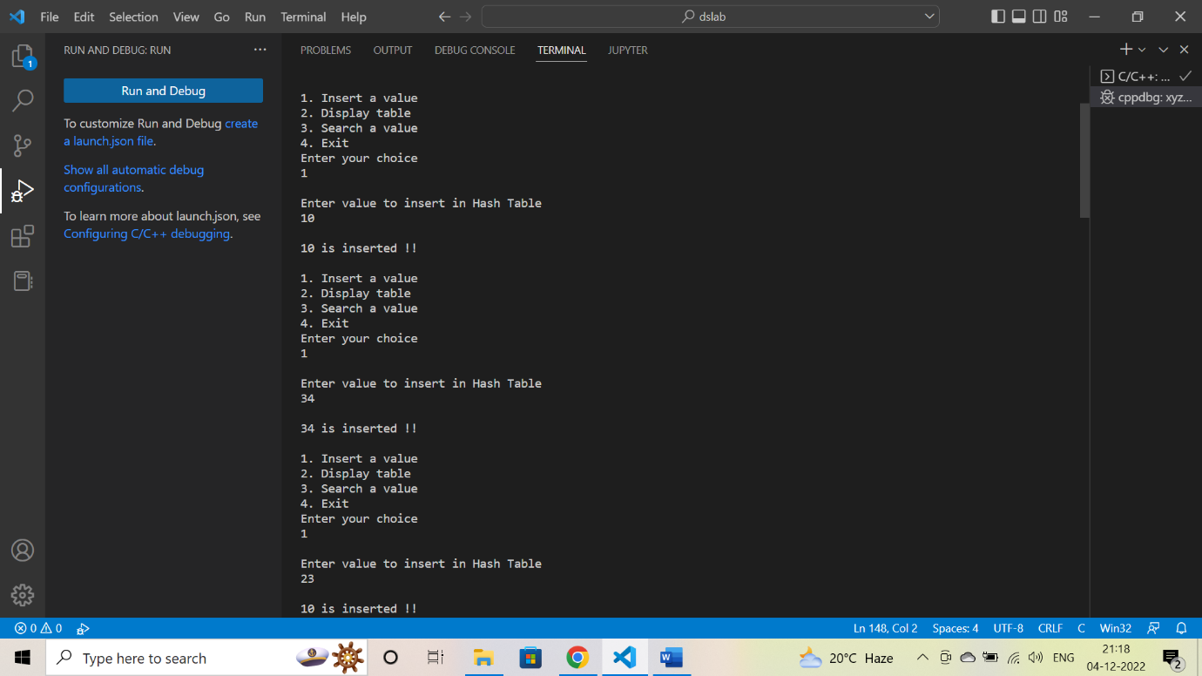

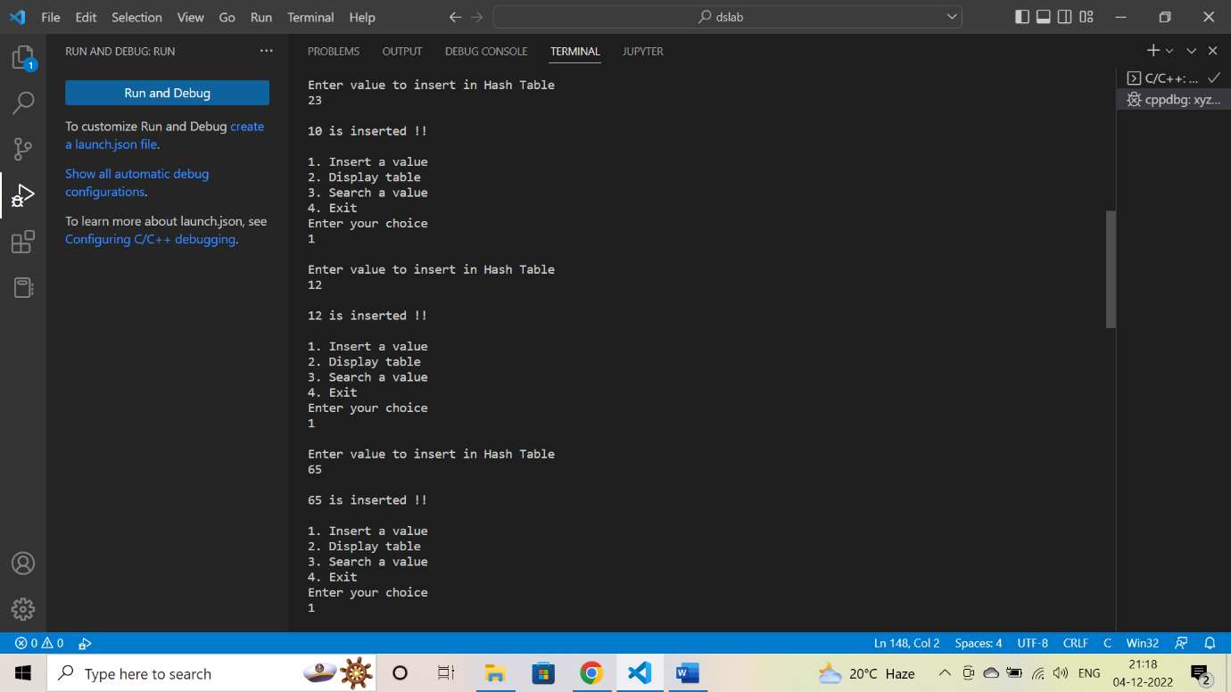

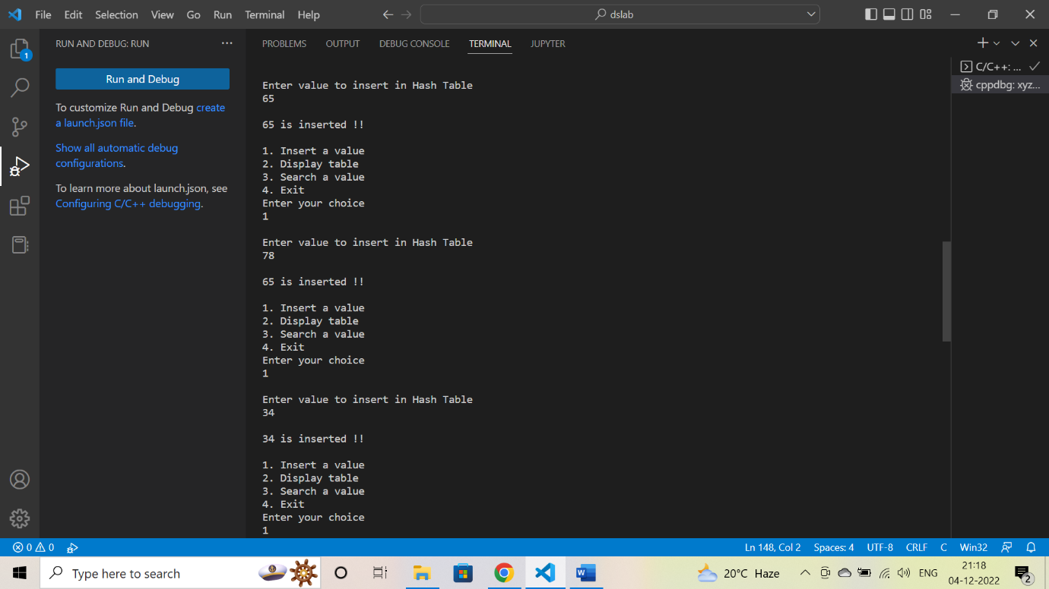

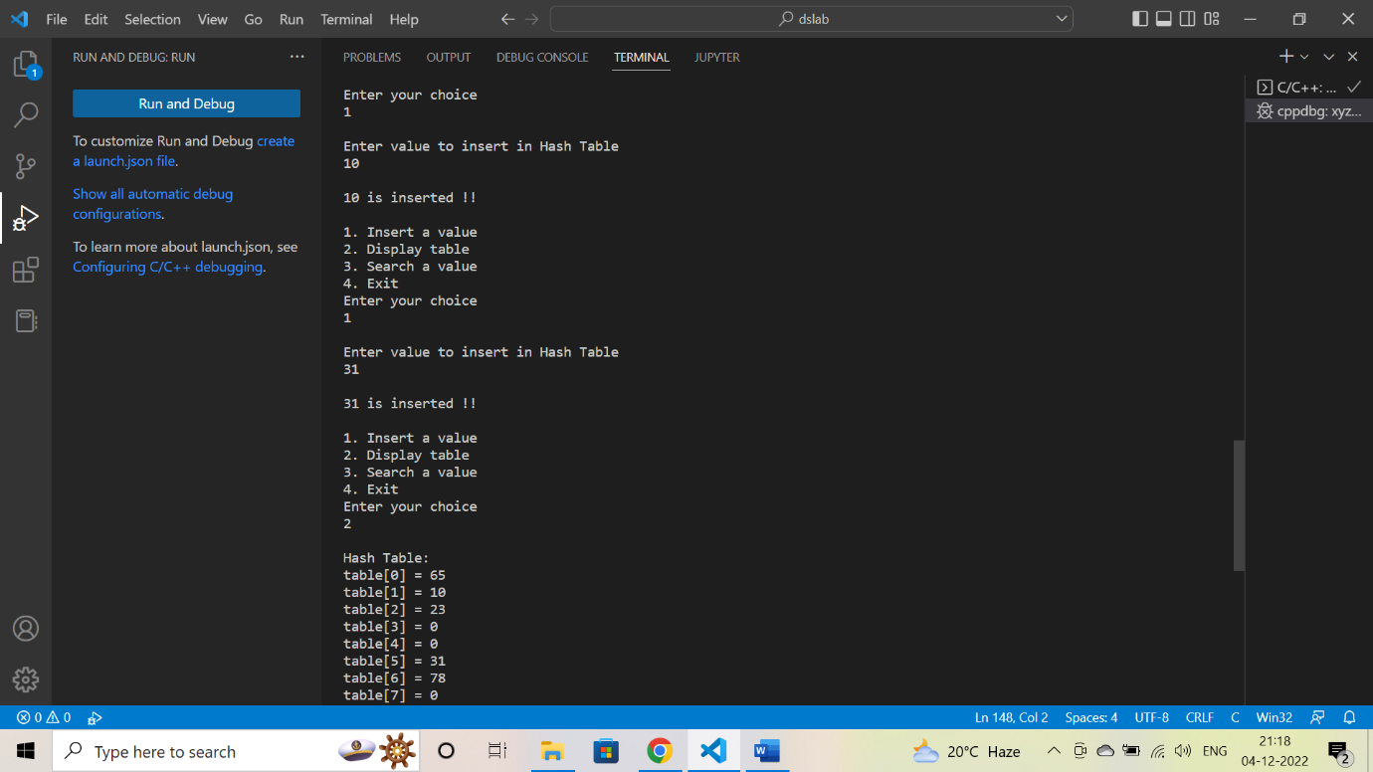

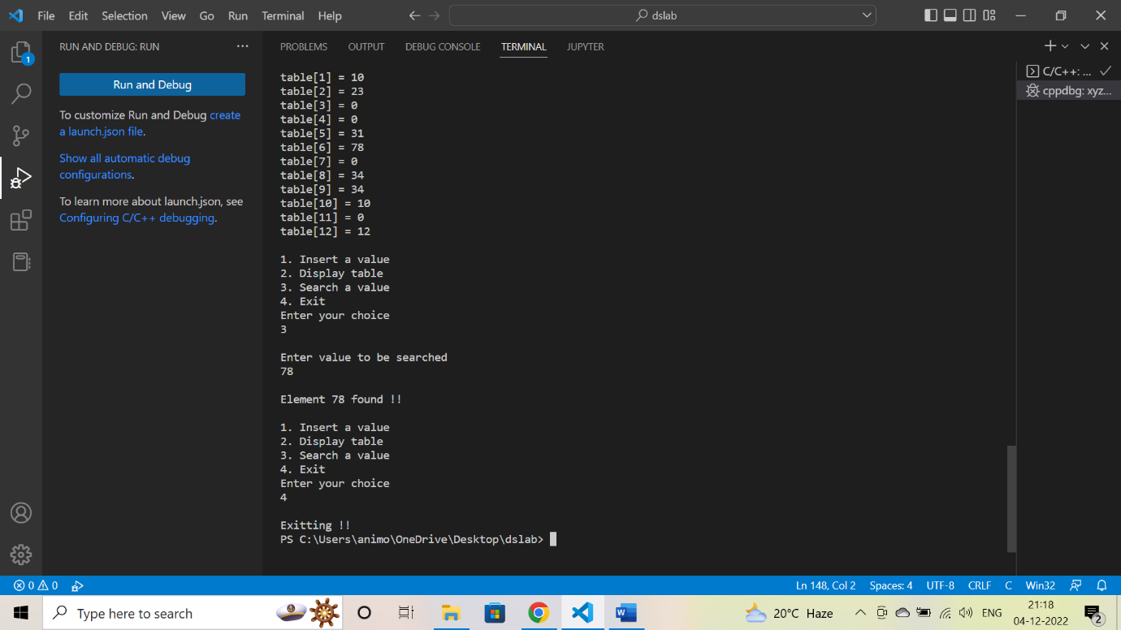

**Assignment: 13**

**EXP**: WAP to implement the following scenarios.

1. Graph representation using adjacency matrix and adjacency list.
2. Graph traversal (BFS and DFS), write the path traversed for the non-weighted graph.
3. Implement Minimum Spanning Tree( Prim+Kruskal) for a weighted graph, and implement the same using both the adjacency matrix and list.

**Coding:**

#include<stdio.h>

#include<stdlib.h>

struct AdjListNode

{

    int dest;

    struct AdjListNode* next;

};

struct AdjList

{

    struct AdjListNode *head;

};

struct Graph

{

    int V;

    struct AdjList* array;

};

struct AdjListNode* newAdjListNode(int dest)

{

    struct AdjListNode* newNode =

     (struct AdjListNode*) malloc(sizeof(struct AdjListNode));

    newNode->dest = dest;

    newNode->next = NULL;

    return newNode;

}

struct Graph* createGraph(int V)

{

    struct Graph* graph =

        (struct Graph*) malloc(sizeof(struct Graph));

    graph->V = V;

    graph->array =

      (struct AdjList*) malloc(V * sizeof(struct AdjList));

    int i;

    for (i = 0; i < V; ++i)

        graph->array[i].head = NULL;

    return graph;

}

void addEdge(struct Graph* graph, int src, int dest)

{

    struct AdjListNode* newNode = newAdjListNode(dest);

    newNode->next = graph->array[src].head;

    graph->array[src].head = newNode;

    newNode = newAdjListNode(src);

    newNode->next = graph->array[dest].head;

    graph->array[dest].head = newNode;

}

void printGraph(struct Graph* graph)

{

    int v;

    for (v = 0; v < graph->V; ++v)

    {

        struct AdjListNode* pCrawl = graph->array[v].head;

        printf("\n Adjacency list of vertex %d\n head ", v);

        while (pCrawl)

        {

            printf("-> %d", pCrawl->dest);

            pCrawl = pCrawl->next;

        }

        printf("\n");

    }

}

void BFS(struct Graph* graph, int s)

{

    int v;

    int visited[graph->V];

    for (v = 0; v < graph->V; v++)

        visited[v] = 0;

    int *queue = (int *)malloc(sizeof(int)*graph->V);

    visited[s] = 1;

    queue[0] = s;

    int i = 0;

    int j = 1;

    while (i < j)

    {

        int u = queue[i];

        printf("%d ", u);

        i++;

        struct AdjListNode* pCrawl = graph->array[u].head;

        while (pCrawl)

        {

            int v = pCrawl->dest;

            if (!visited[v])

            {

                visited[v] = 1;

                queue[j] = v;

                j++;

            }

            pCrawl = pCrawl->next;

        }

    }

}

void DFS(struct Graph* graph, int s)

{

    int v;

    int visited[graph->V];

    for (v = 0; v < graph->V; v++)

        visited[v] = 0;

    int *stack = (int *)malloc(sizeof(int)*graph->V);

    visited[s] = 1;

    stack[0] = s;

    int i = 0;

    int j = 1;

    while (i < j)

    {

        int u = stack[i];

        printf("%d ", u);

        i++;

        struct AdjListNode* pCrawl = graph->array[u].head;

        while (pCrawl)

        {

            int v = pCrawl->dest;

            if (!visited[v])

            {

                visited[v] = 1;

                stack[j] = v;

                j++;

            }

            pCrawl = pCrawl->next;

        }

    }

}

int main()

{

    int V = 5;

    struct Graph* graph = createGraph(V);

    addEdge(graph, 0, 1);

    addEdge(graph, 0, 4);

    addEdge(graph, 1, 2);

    addEdge(graph, 1, 3);

    addEdge(graph, 1, 4);

    addEdge(graph, 2, 3);

    addEdge(graph, 3, 4);

    printGraph(graph);

    int s = 0;

    printf("\nBFS starting from vertex %d : ", s);

    BFS(graph, s);

    s = 0;

    printf("\nDFS starting from vertex %d : ", s);

    DFS(graph, s);

    return 0;

}

**Output:**

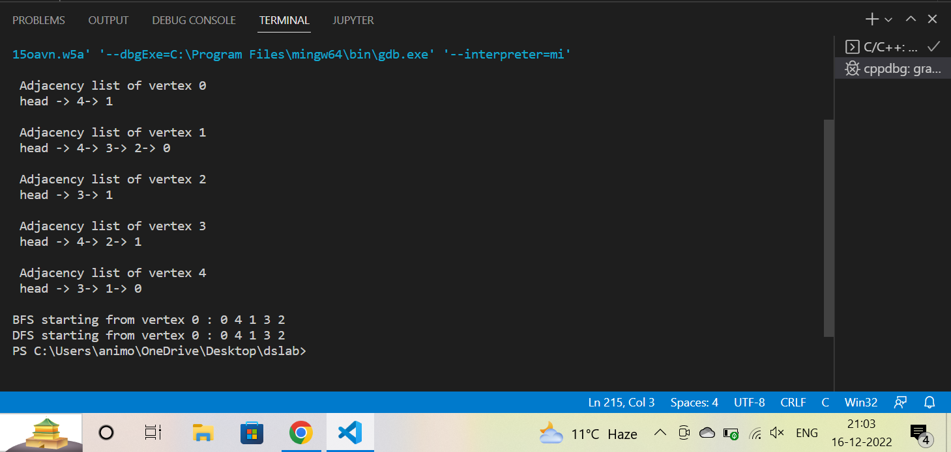

**DATA STRUCTURES VIVA :1**

1. **Print a pattern of numbers from 1 to n as shown below. Each of the numbers is separated by a single space.**

**Coding:**

#include <stdio.h>

int main()

{

    int a,b,c,x,y,z;

printf("Enter a Number: ",y);

    scanf("%d",&y);

    c=y;

    x = y+(y-1);

    for(a=0;a<x;a++)

    {

        for(b=0;b<x;b++)

        {

            if(a<=y-1)

            {

                if(a==0)

                {

                printf("%d ",c);

                }

                if(a>=1)

                {

                    if(b<a)

                    {

                        printf("%d ",c-b);

                    }

                    else if(b>=a && b<x-a)

                    {

                        printf("%d ",c-a);

                    }

                    else

                    {

                        printf("%d ",(b-c+1)+1);

                    }

                }

            }

            else if(a==y-1)

            {

                if(b<y)

                {

                    printf("%d ",c-b);

                }

                else

                {

                    printf("%d ",(b-c+1)+1);

                }

            }

            else if(a>=y)

            {

                z = x-a-1;

                if(a==x)

                {

                printf("%d ",c);

                }

                if(b<z)

                {

                    printf("%d ",c-b);

                }

                else if(b>=z && b<x-z)

                {

                    printf("%d ",c-z);

                }

                else

                {

                    printf("%d ",(b-c+1)+1);

                }

            }

        }

        printf("\n");

    }

}

**Output:**

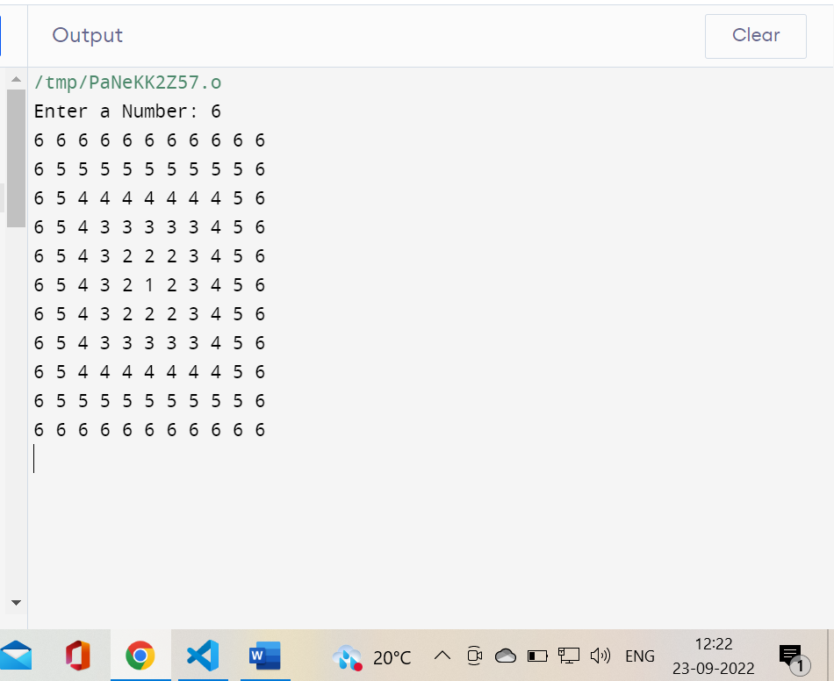

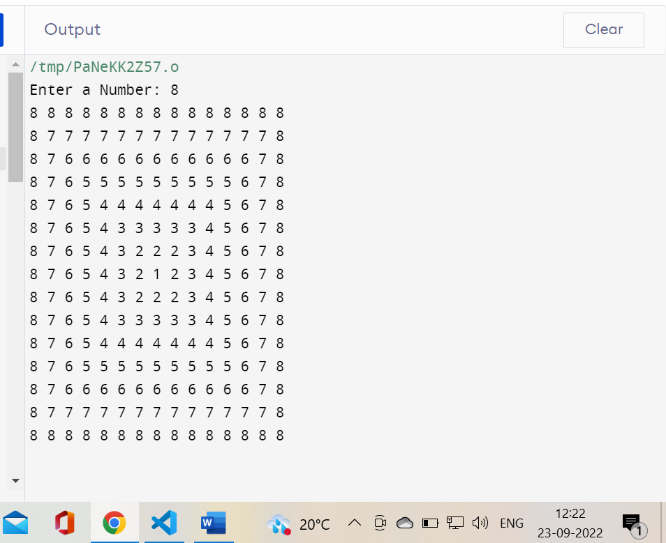

**Viva 2**

Exp. Create a linked list with the following records, name, age, and place.

Search for the place, if the place is Delhi, replace it with New Delhi.

Delete the entries where the age is greater than 90 years.

**Coding:**

#include <stdlib.h>

#include <string.h>

#include <stdio.h>

struct Student

{

    int age;

    char name[100];

    char place[100];

    struct Student *next;

} * head;

void insert(int age, char *name, char *place)

{

    struct Student *student = (struct Student *)malloc(sizeof(struct Student));

    student->age = age;

    strcpy(student->name, name);

    strcpy(student->place, place);

    student->next = NULL;

    if (head == NULL)

    {

        head = student;

    }

    else

    {

        student->next = head;

        head = student;

    }

}

void search(int age)

{

    struct Student *temp = head;

    while (temp != NULL)

    {

        if (temp->age == age)

        {

            printf("Age: %d\n", temp->age);

            printf("Name: %s\n", temp->name);

            printf("Place: %s\n", temp->place);

            return;

        }

        temp = temp->next;

    }

    printf("Student with Age %d is not found !!!\n", age);

}

void update(int age)

{

    struct Student *temp = head;

    while (temp != NULL)

    {

        if (temp->age == age)

        {

            printf("Record with age %d Found !!!\n", age);

            printf("Enter new name: ");

            scanf("%s", temp->name);

            printf("Enter new place: ");

            scanf("%s", temp->place);

            printf("Updation Successful!!!\n");

            return;

        }

        temp = temp->next;

    }

    printf("Student with age %d is not found !!!\n", age);

}

void Delete(int age)

{

    struct Student *temp1 = head;

    struct Student *temp2 = head;

    while (temp1 != NULL)

    {

        if (temp1->age == age)

        {

            printf("Record with age %d Found !!!\n", age);

            if (temp1 == temp2)

            {

                head = head->next;

                free(temp1);

            }

            else

            {

                temp2->next = temp1->next;

                free(temp1);

            }

            printf("Record Successfully Deleted !!!\n");

            return;

        }

        temp2 = temp1;

        temp1 = temp1->next;

    }

    printf("Student with age %d is not found !!!\n", age);

}

void display()

{

    struct Student *temp = head;

    while (temp != NULL)

    {

        printf("Age: %d\n", temp->age);

        printf("Name: %s\n", temp->name);

        printf("Place: %s\n", temp->place);

        temp = temp->next;

    }

}

int main()

{

    head = NULL;

    int choice;

    int age;

    char name[100];

    char place[100];

    printf("1. insert student details\n2. search for student details\n3.delete student details\n4.update student details\n5. display all student details");

    do

    {

        printf("\nEnter Choice: ");

        scanf("%d", &choice);

        switch (choice)

        {

        case 1:

            printf("Enter Age: ");

            scanf("%d", &age);

            printf("Enter Name: ");

            scanf("%s", name);

            printf("Enter place: ");

            scanf("%s", place);

            insert(age, name, place);

            break;

        case 2:

            printf("Enter age to search: ");

            scanf("%d", &age);

            search(age);

            break;

        case 3:

            printf("Enter age to search: ");

            scanf("%d", &age);

            Delete(age);

            break;

        case 4:

            printf("Enter age to search: ");

            scanf("%d", &age);

            update(age);

            break;

        case 5:

            display();

            break;

        }

    } while (choice != 0);

}

**Screenshot:**

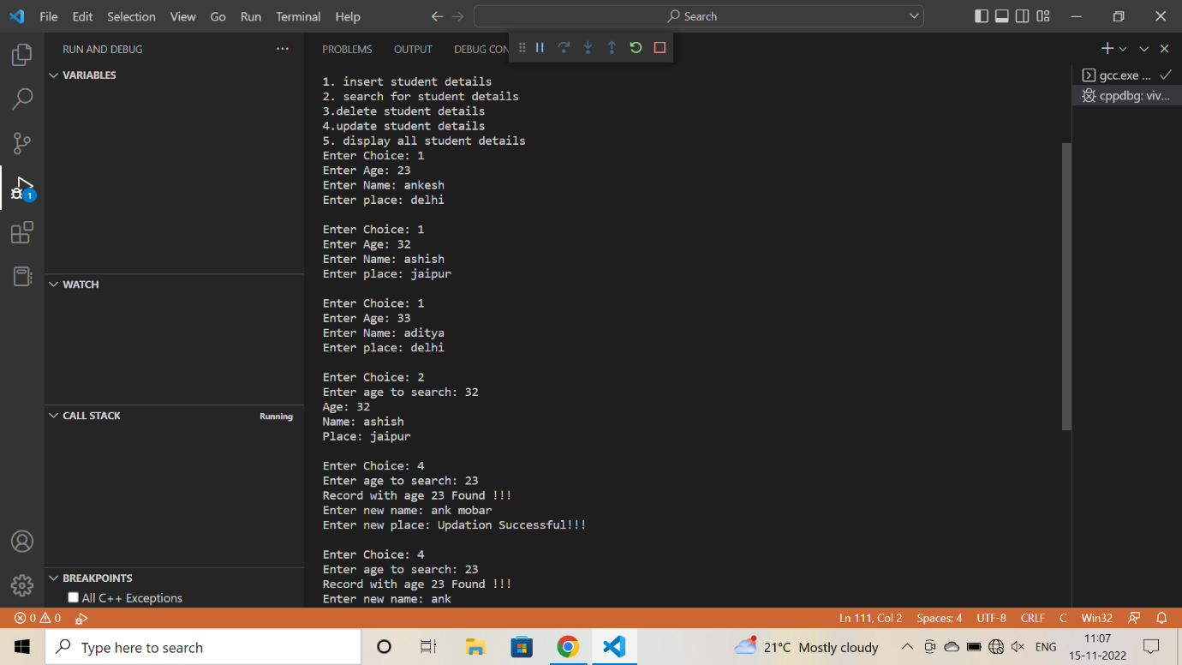

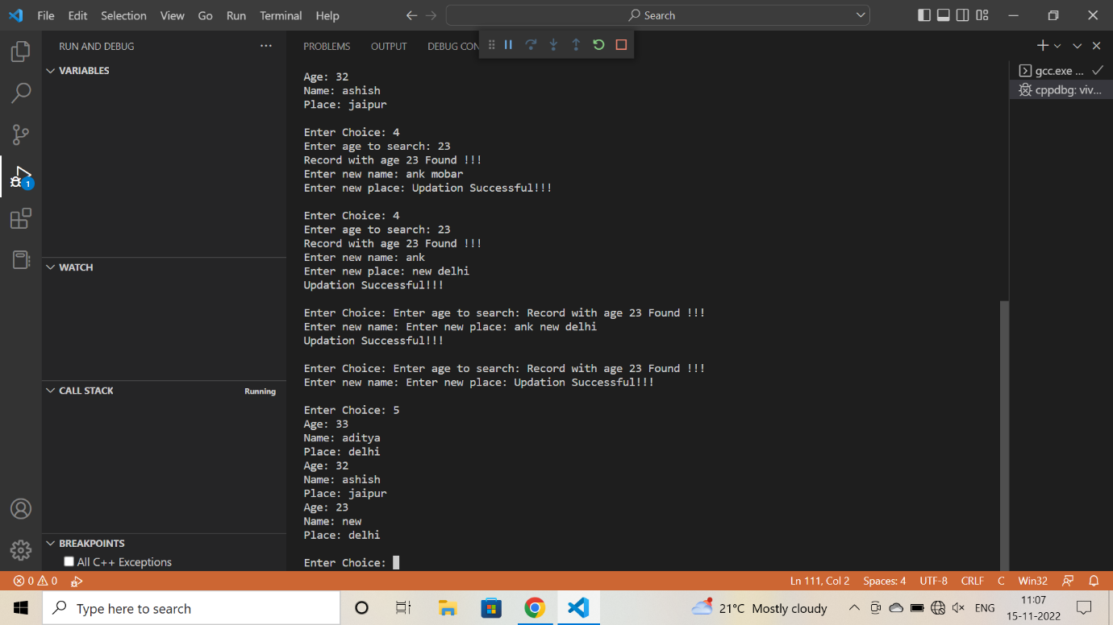

**Viva 3**

**EXP. Write a C program**

1. **Check if the given Binary tree is BST or not. \***
2. **For a given binary search tree, print the in-order traversal. \***
3. **For a given Binary tree, print the leaf nodes of the tree. \***
4. **For the given BST, print the sum of all the nodes.**
5. **For a given BST, check if the tree is a complete binary tree or not, and use the balance factor to determine it.**
6. **In a BST Insert element at a specified location.**
7. **Delete the root node from BST for a given input. \***

**Coding:**

#include<stdio.h>

#include<stdlib.h>

struct node

{

    int data;

    struct node* left;

    struct node* right;

};

struct node* insert(struct node* root, int data)

{

    if (root==NULL)

    {

       root = (struct node*)malloc(sizeof(struct node));

       root->data = data;

       root->left = root->right = NULL;

    }

    else if (data < root->data)

       root->left = insert(root->left,data);

    else

       root->right = insert(root->right,data);

    return root;

}

int isBSTUtil(struct node* root, int min, int max)

{

    if (root==NULL)

        return 1;

     if (root->data < min || root->data > max)

        return 0;

     return

         isBSTUtil(root->left, min, root->data-1) &&

         isBSTUtil(root->right, root->data+1, max);

}

int isBST(struct node* root)

{

     return(isBSTUtil(root, INT_MIN, INT_MAX));

}

void printInorder(struct node* root)

{

    if (root == NULL)

        return;

    printInorder(root->left);

    printf("%d \n", root->data);

    printInorder(root->right);

}

void deleteNode(struct node* root,int data)

{

    struct node *curr, *parent, *successor, *temp ;

    curr = root;

    while(curr->data != data)

    {

        parent = curr;

        curr = (data < curr->data)? curr->left: curr->right;

        if(curr == NULL)

            return;

    }

    // node with no children

    if(curr->left == NULL && curr->right == NULL)

    {

        if(curr == root)

        {

            root = NULL;

        }

        else if(curr == parent->left)

        {

            parent->left = NULL;

        }

        else

        {

            parent->right = NULL;

        }

        free(curr);

    }

    // node with one child

    else if(curr->left == NULL || curr->right == NULL)

    {

        if(curr == root)

        {

            if(curr->left == NULL)

                root = curr->right;

            else

                root = curr->left;

            free(curr);

        }

        else if(curr == parent->left)

        {

            if(curr->left == NULL)

            {

                parent->left = curr->right;

            }

            else

            {

                parent->left = curr->left;

            }

            free(curr);

        }

        else

        {

            if(curr->left == NULL)

            {

                parent->right = curr->right;

            }

            else

            {

                parent->right = curr->left;

            }

            free(curr);

        }

    }

    // node with two children: get the inorder successor

    else

    {

        temp = curr->right;

        while(temp->left)

            temp = temp->left;

        successor = temp;

        deleteNode(root,successor->data);

        curr->data = successor->data;

    }

}

/* Function to get the count of leaf nodes in a binary search tree*/

unsigned int getLeafCount(struct node* node)

{

  if(node == NULL)

    return 0;

  if(node->left == NULL && node->right==NULL)

    return 1;

  else

    return getLeafCount(node->left)+

           getLeafCount(node->right);

}

int main()

{

    struct node* root=NULL;

    int data, choice;

    while(1)

    {

        printf("\n******** MENU ********\n");

        printf("1. Insert\n");

        printf("2. Check BST\n");

        printf("3. Print Inorder\n");

        printf("4. Delete from tree\n");

        printf("5. Exit\n");

        printf("*********************\n");

        printf("\nEnter your choice: ");

        scanf("%d", &choice);

        printf("Leaf count of the tree is %d\n", getLeafCount(root));

        switch(choice)

        {

        case 1:

            printf("Enter the data to be inserted: ");

            scanf("%d", &data);

            root = insert(root,data);

            break;

        case 2:

            if(isBST(root))

                printf("It is a BST\n");

            else

                printf("It is not a BST\n");

            break;

        case 3:

            printf("In-order traversal :\n");

            printInorder(root);

            break;

        case 4:

            printf("Enter the data to be deleted: ");

            scanf("%d", &data);

            deleteNode(root,data);

            break;

        case 5:

            exit(0);

            break;

        default:

            printf("Wrong choice\n");

        }

    }

    return 0;

}

**Output:**

**IF BST**

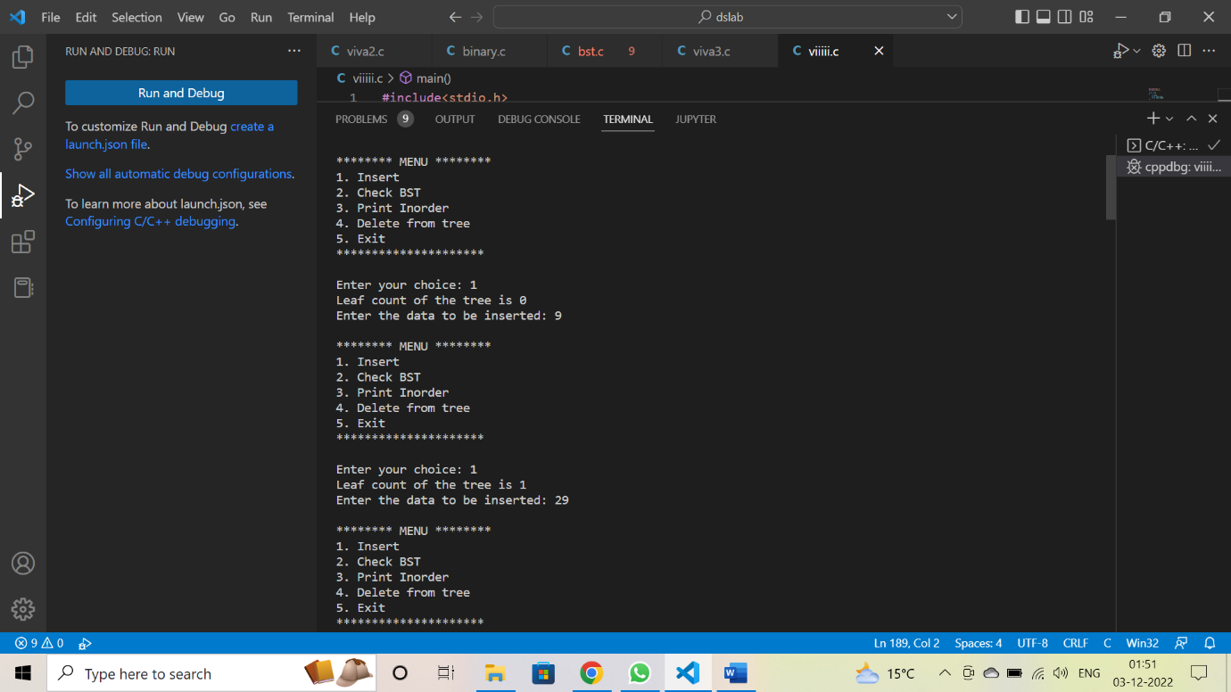

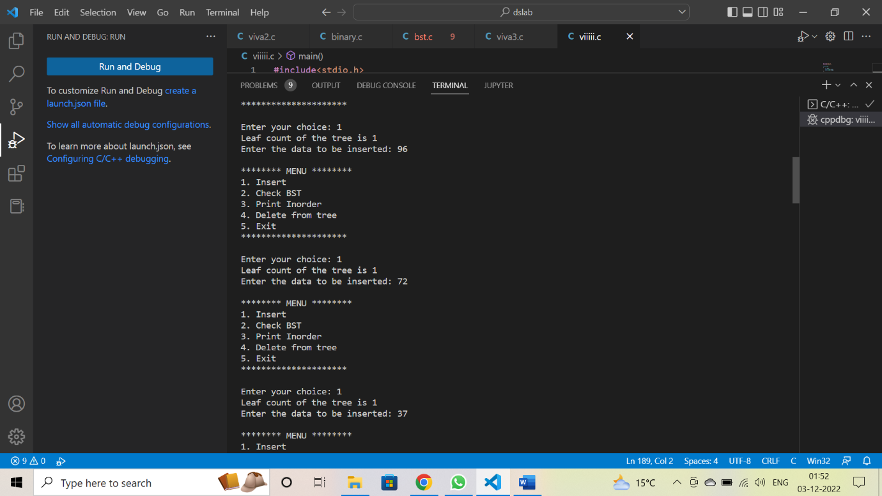

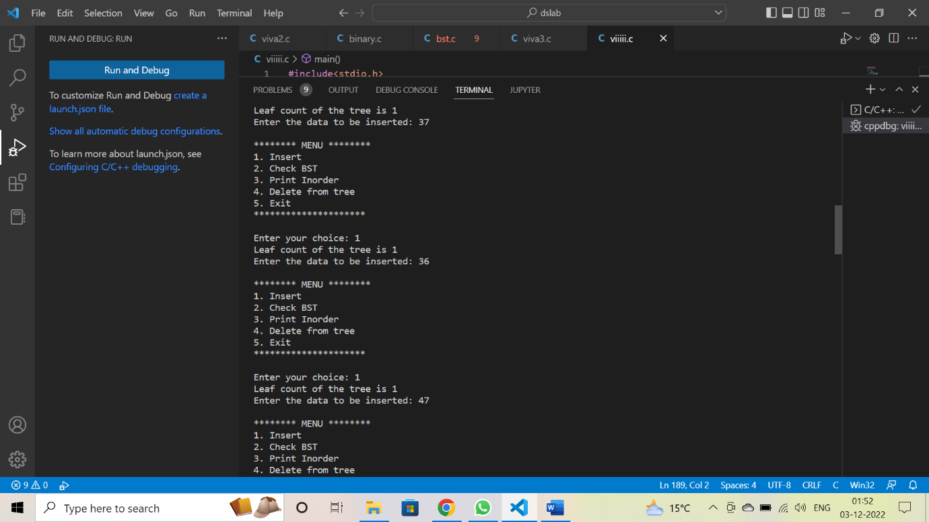

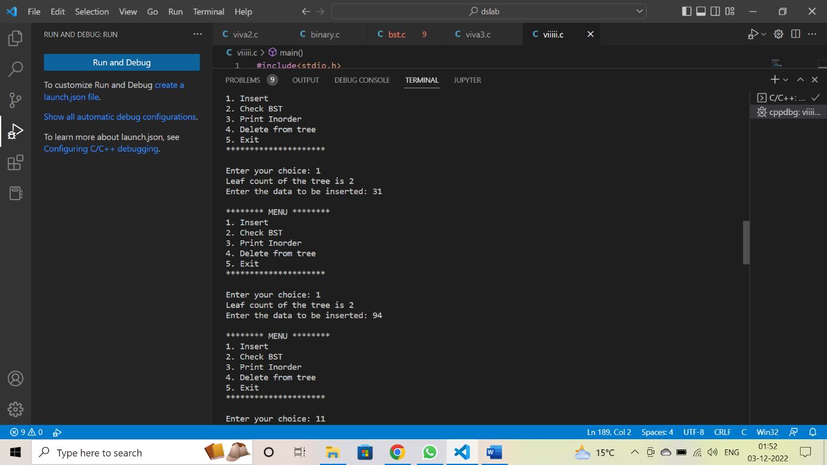

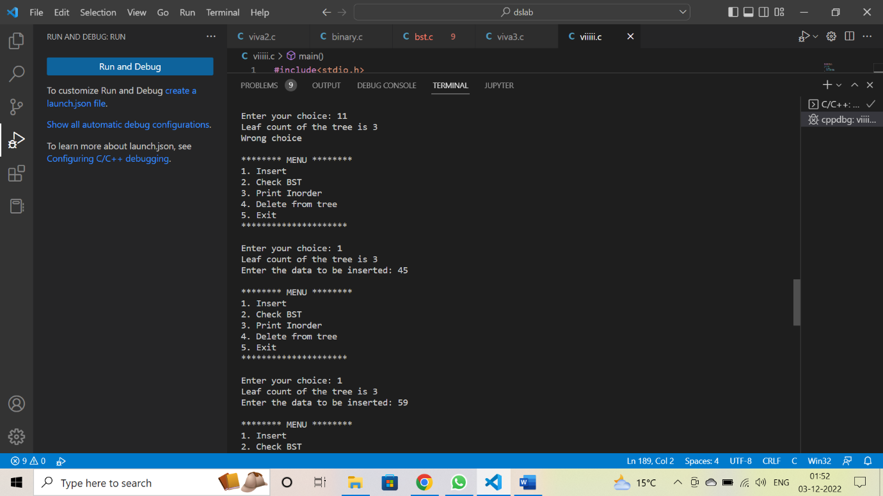

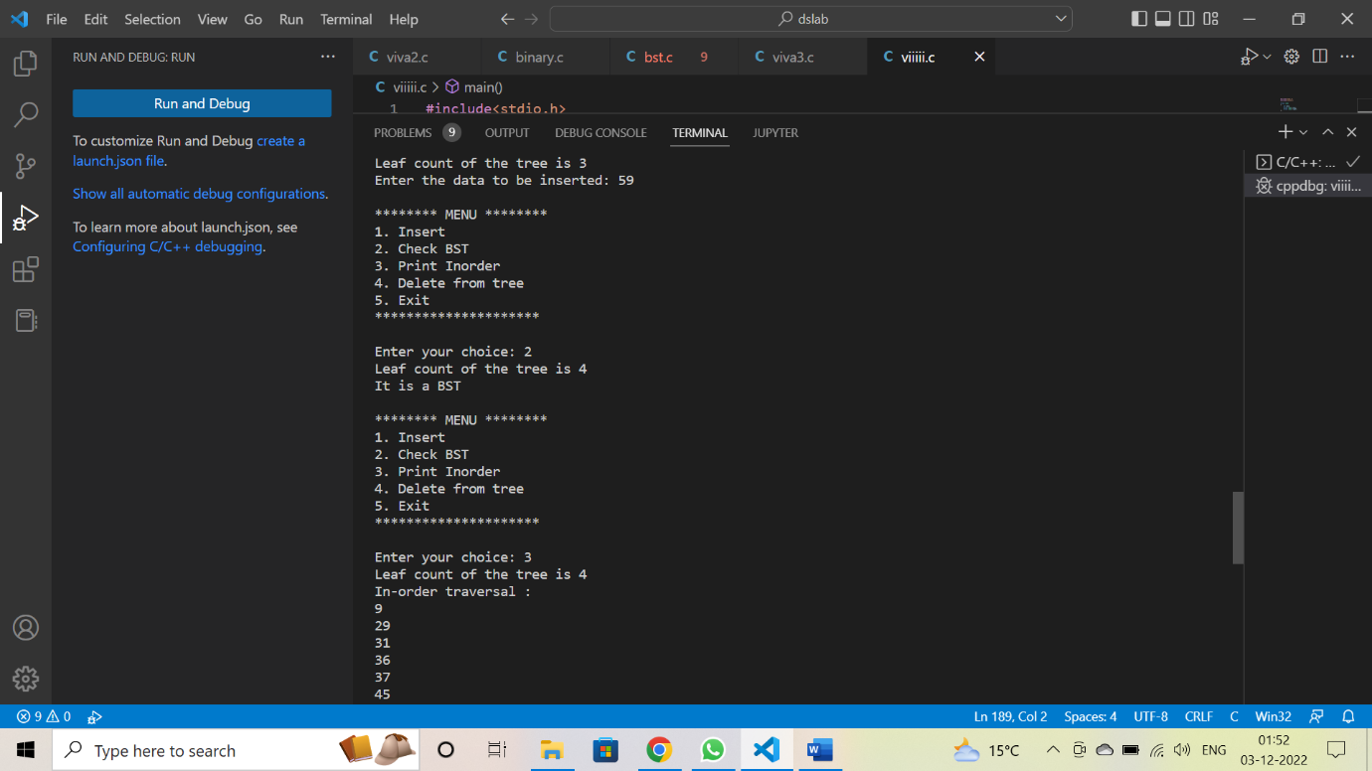

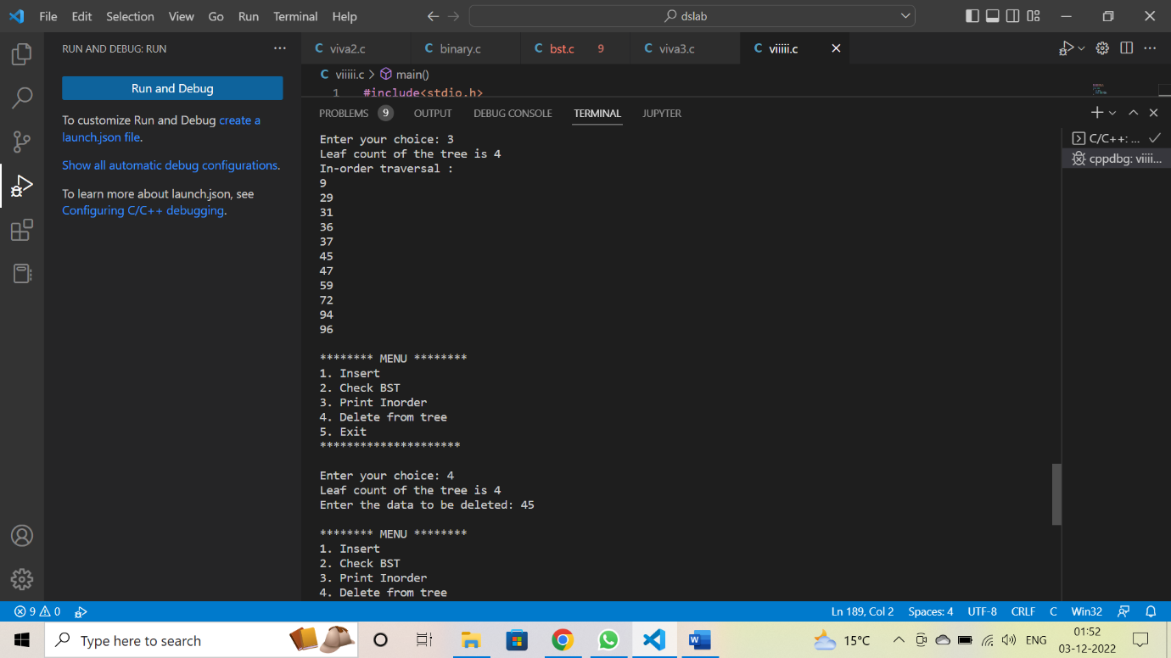

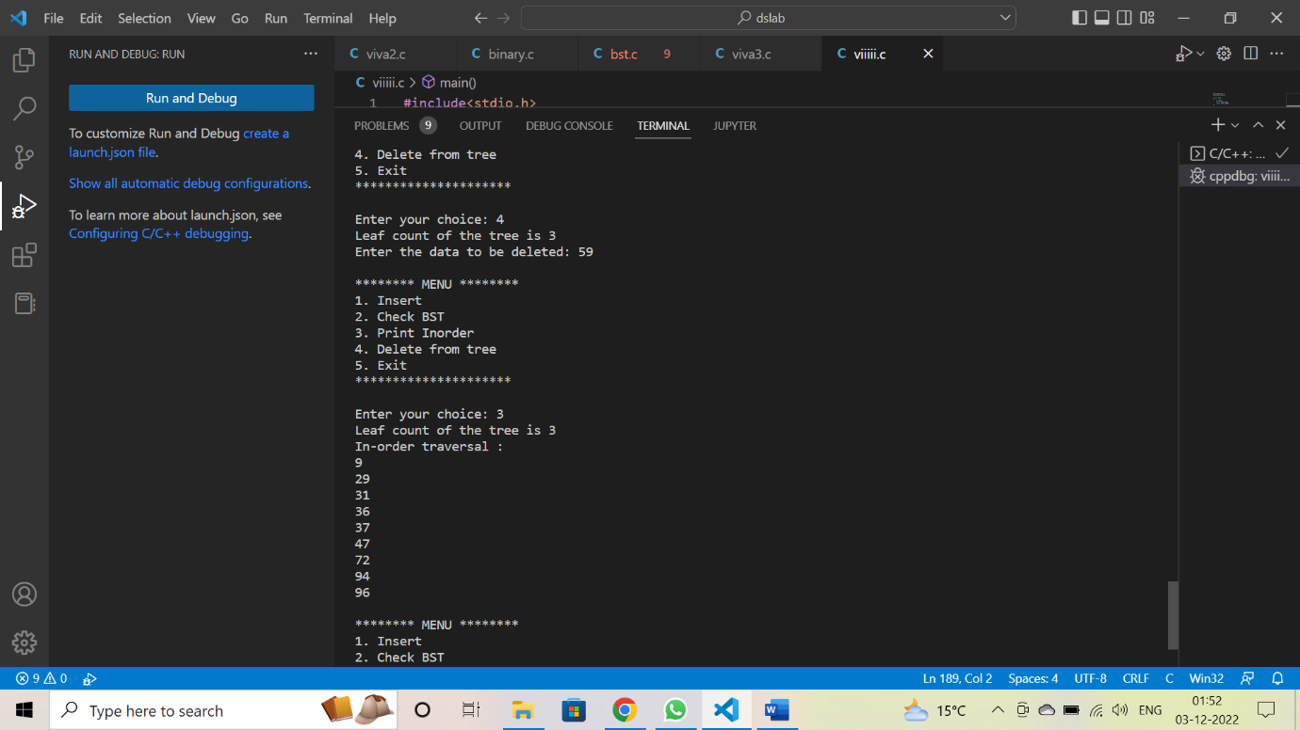

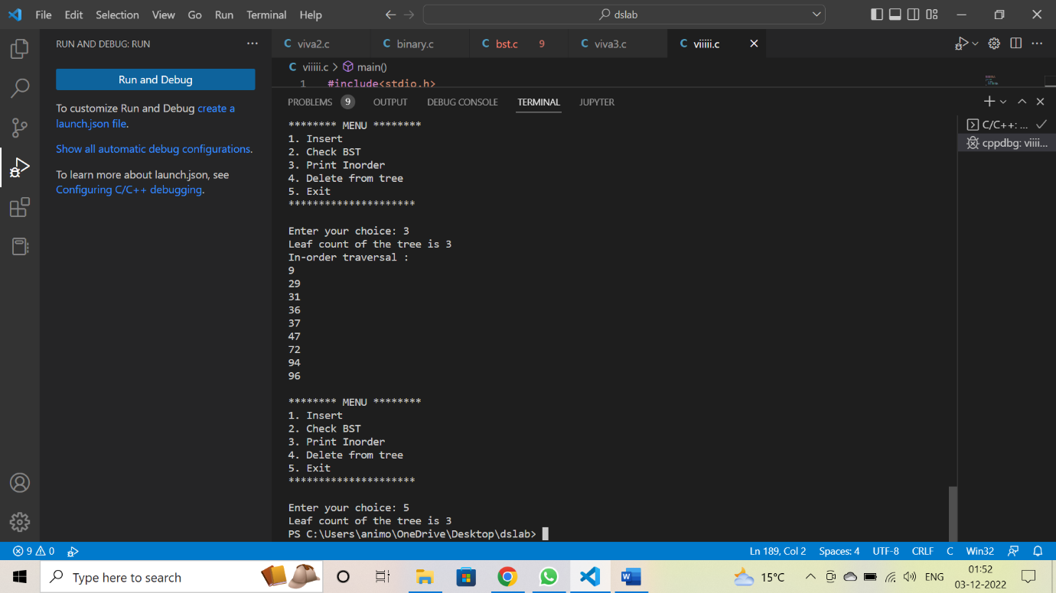

**IF IT is not a BST**

